Language Representation &
Semantic Spaces in NLP & AI

2024-2025

Table of Contents
1 Table of Contents 1-2
2 Table of Figures 2-4
3 Abstract 3-5
4 Preamble: The Imitation Game 4-6
4.1 Natural Language Processing (NLP) & AI 4-7
4.2 Natural Language Understanding (NLU) 4-11
4.3 Language Theory 4-11
4.3.1 Formal Grammar and Automata Theory 4-12
4.3.2 Distributional Semantics: 4-12
4.4 Historical Context of NLP & NLU 4-12
4.4.1 Early Years: 1950-1980 4-13
4.4.2 Statistical & probabilistic (ML) Approaches: 1980s and 1990s 4-14
4.4.3 Deep Learning, Transformers & Modern NLP: 2000s-Present 4-14
4.4.4 2010s-Present: Transformer Models and Beyond 4-15
4.4.5 Key Papers & Milestones 4-15
4.5 Computational Linguistics 4-17
4.5.1 Key Activities in Computational Linguistics: 4-17
4.5.2 Differences Between Computational Linguistics, NLP, and AI 4-18
4.5.3 Current Status 4-18
4.5.4 Summary 4-19
4.6 Modern NLP & AI Applications 4-19
4.7 Current Areas of Research & Development 4-21
4.8 Summary 4-22
5 Language Representation in NLP & AI 5-22
5.1 Feature Selection in Semantic (Vector) Space 5-23
5.1.1 Latent Semantic Analysis or Latent Semantic Indexing 5-26
5.2 The Distributional Hypothesis & Word Embeddings 5-28
5.2.1 Tokenization 5-30
5.2.2 Word2Vec 5-32
5.2.3 GloVe 5-33
5.2.4 FastText 5-34
5.3 Contextual Representations: Autoencoders, Attention Mechanisms & Transformers 5-35
5.3.1 ELMo & Bidirectional LSTMs 5-36
5.3.2 Transformers & Attention Mechanisms 5-37
5.3.3 BERT 5-38
5.4 Alternative Forms of Representation 5-40
5.4.1 Sentence and Document Embeddings 5-40
5.4.2 Quantum Language Models 5-40
5.5 Key Papers and References 5-42
5.6 Latest Developments and Research 5-43
5.7 Use of Embeddings in NLP Solves 5-44
5.7.1 Frequency Based Construction 5-44
5.7.2 Co-Occurrence Based Methods 5-45
5.7.3 Contextualized Embeddings 5-47
6 Large Language Models 6-51
6.1 LLaMA (Meta) 6-52
6.2 ChatGPT (OpenAI) 6-52
6.3 PaLM (Google) 6-52
6.4 Claude (Anthropic) 6-52
7 Summary 7-53
8 Bibliography 8-54
8.1 Misc 8-56

Table of Figures

Figure 1: Generative AI 4-8
Figure 2: AI emergence across R&D from a variety of fields 4-9
Figure 3: NLP, AI, and Computer Science 4-10
Figure 4: Chomsky's Hierarchy of Languages (Fitch, 2010) 4-12
Figure 5: NLP R&D Timeline and Major Developments 4-16
Figure 6: The field of Computational Linguistics 4-17
Figure 7: Typical NLP Text Pipeline 4-20
Figure 8: Semantic Space and Word Similarity 5-26
Figure 9: Latent Semantic Indexing using Singular Value Decomposition (Patel, 2019) 5-27
Figure 10: SVD in terms of scaling and rotation of vectors in Euclidean space 5-27
Figure 11: document query in vector space 5-28
Figure 13: Word Embeddings & Similarity Vectors 5-29
Figure 14: Typical NLP Pipeline (Albrecht, et al., 2020) 5-31
Figure 16: Word2Vec algorithmic design 5-33
Figure 17: GloVe embeddings with statistical co-occurrence 5-34
Figure 18: ELMo Objective Function Neural Network (bidirectional LSTM) Architecture 5-36
Figure 19: Transformer architecture 5-39
Figure 20: Bidirectional Encoder Representation from Transformers Architecture (BERT) 5-40
Figure 21: Language Model Evolutionary Tree (Yang, et al., 2023) 6-51
Figure 22: LLM Families and their Development (Zhao, et al., 2023) 6-52

Abstract

Natural Language Processing (NLP) is one of the most dominant and influential fields in artificial intelligence (AI) today, providing much of the theoretical and functional underpinnings for some of the most widely adopted ai applications on the market - applications such as Siri from Apple or Alexa from Amazon and ChatGPT from OpenAI, each of which is developed using the NLP practices and foundations that have been developed in Computer Science research communities over the last century. Acceleration, adoption, and research has accelerated in the last few years however, mainly due to the applications mentioned above which have come to the market which represent the culmination of this research combined with the availability of computational power and network infrastructure which makes these applications possible.

This work intends to focus on the underlying data structures and techniques that are used in the creation of what have come to be known in the industry and research literature as language models, or LLMs (large language models), which typically implies that such models are pre-trained and available for use in a wide array of NLP applications and in some cases even available via APIs for integration into applications. While there have been a few very good studies that survey the language representation and language model landscape (such as xxxx), we intend to focus here on just a few of the most widely discussed and industry relevant models, focusing on their underlying structure and method of creation, with a bent toward shedding light on how it is that such models have become so good at understanding natural language. As such, we will look toward the GLUE benchmark as a means of measuring the capabilities of such models, as well as a baseline for the notion of (natural language) understanding in this context.

Ultimately, we look to answer, or provide color, for the following questions with respect to this work = How is that the applications that are flooding the market today are so good at understanding natural language and given the current methods of construction of such models what are their inherent limitations.

Keywords:

language representation, language models, large language models, LLMs, text representation learning, NLP, Natural Language Processing, Vector Space Models, Semantic Spaces, Word Embeddings, Representation Learning, Text Vectorization, Machine Learning, AI, Artificial Intelligence, quantum language representation, quantum NLP

Preamble: The Imitation Game
We find ourselves in the modern world, with the introduction and now widespread use of AI technology, eerily in that place that Alan Turing, one of the fathers of the AI field, described in one of his most influential and famous works, an article published in a journal called Mind all the way back in 1950. The piece opens with the following introduction, under a heading which is infamously called the Imitation Game, a game we undoubtedly find ourselves smack in the middle of at present.

I PROPOSE to consider the question, ' Can machines think?' This should begin with definitions of the meaning of the terms 'machine' and 'think'. The definitions might be framed so as to reflect so far as possible the normal use of the words, but this attitude is dangerous. If the meaning of the words 'machine' and 'think' are to be found by examining how they are commonly used it is difficult to escape the conclusion that the meaning and the answer to the question, 'Can machines think?' is to be sought in a statistical survey such as a Gallup poll. But this is absurd. Instead of attempting such a definition I shall replace the question by another, which is closely related to it and is expressed in relatively unambiguous words. The new form of the problem can be described in terms of a game which we call the 'imitation game'. It is played with three people, a man (A), a woman (B}, and an interrogator (C) who may be of either sex. The interrogator stays in a room apart from the other two. The object of the game for the interrogator is to determine which of the other two is the man and which is the woman. He knows them by labels X and Y, and at the end of the game he says either ‘X is A and Y is B’ or ‘X is B and Y is A’. (Turing, 1950)

Turing goes on to describe the details of the game as well as the design of ‘digital computers’, and how it is that they can be designed so as to win the game so to speak, to be designed such that their behavior – as analyzed from a linguistic output standpoint – can ultimately be indistinguishable from a human beings and as such usher in an era where at least from a certain perspective humans and machines are indistinguishable.

The era has arrived, and yet many of the objections and issues that Turing brings up remain relevant even today, some 75 years after that article is published.

What we look to do with this work is describe the inner workings of the underlying machine learning technology that drives this behavior, the imitation game as it were, and perhaps address at least some of the questions that Turing raises in his original work on the subject, and ultimately – if we are lucky – helping to shed light on the question of the difference between human and machine intelligence, as we understand and know the latter to be today with respect to the applications that have been developed off of language models, the architecture of which we will describe in detail in this work.

This work intends to focus on the underlying data structures and techniques that are used in the creation of what have come to be known in the industry and research literature as language models, or LLMs (large language models), which typically implies that such models are pre-trained and available for use in a wide array of NLP applications and in some cases even available via APIs for integration into applications. While there have been many very good studies that survey the NLP landscape with a. focus in particular on language models and how they are architected, trained and function, we intend to focus here on just a few of the most widely discussed and industry relevant models, detailing their underlying architecture, method of construction and training, with a bent toward shedding light on how it is that such models have become so good at understanding natural language (Chang & Bergen, 2024) (Bender & Koller, 2020) (Mitchell & Krakauer, 2023) (Shardlow & Przybyła, 2023).

As such, we will look at the underlying linguistic theory which underpins natural language processing (NLP) and natural language understanding (NLU) in general, look at the major milestones and advances in NLP research in the last decade or so which have driven innovation in NLP and AI, review the framework that specifically focuses on benchmarking understanding in language models (the GLUE framework – TODO add reference), and take a detailed look at some of the prominent architectures which are used by some of the major language models in the market today (GPT, Llama, BERT, Word2Vec, …..), and analyze how it is that these language models are able to understand text, natural language, as it is currently understood and defined within the fields of NLP and Computational Linguistics as they are currently defined.

This paper looks at the development of these various techniques, leveraging a variety of statistical methods which rest on linguistic theories that were advanced in the middle of the last century, namely the distributional hypothesis which suggest that word that are found in similar contexts generally have similar meanings. In this survey paper we look at the development of some of the most popular of these techniques from a mathematical as well as data structure perspective, from Latent Semantic Analysis to Vector Space Models to their more modern variants which are typically referred to as word embeddings. In this review of algorithms such as Word2Vec, GloVe, ELMo and BERT, we explore the idea of semantic spaces more generally beyond applicability to NLP.

Ultimately, we look to answer, or provide color, for the following questions with respect to this work: How is that the applications that are flooding the market today are so good at understanding natural language and given the current methods of construction of such models what their inherent limitations (if any) are.

This work is organized with an introduction to NLP, marking the major developments and milestones from a technological research and development perspective that have brought us to where we are today from an NLP and AI perspective, followed by a brief review of the GLUE benchmark and its relevance to this discussion. We then discuss the theoretical underpinnings of modern language models in general, followed by a detailed exposition of several of the most market relevant models in the marketplace today. We then close with a review of the quantum mechanics inspired models (aka Quantum Language Models) which serve as a good example of comparison as an alternate form of language representation, closing with a brief summary and discussion of state of language model development as it stands today and where it is likely headed.

Natural Language Processing (NLP) & AI

Artificial Intelligence comes in many forms - whether in the form of automated care driving systems, image recognition and classification systems, robotics, and perhaps the most influential and widespread in today’s technological landscape as generative AI, the latter being the term that is used for the class of AI systems that is able to generate new content which includes audio, images, code, text and even videos. It is these generative AI applications which have taken the technology world by storm since the market release of ChatGPT in November 2022 that are the subject of this work, the underlying language models themselves in particular which is more or less where the ‘intelligence’ part of these models lives.

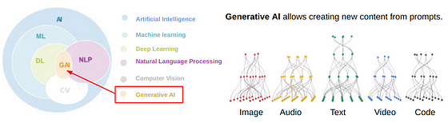
Figure 1: Generative AI

To understand and appreciate how it is that these generative models do such a good job at emulating human intelligence, we take a deep dive here into the underlying architecture of some of the latest language models that have been released by some of the largest technology players in the market – namely Google’s Gemini, Meta’s Llama, Anthropic’s Claude, and Open AI’s ChatGPT.

To have a solid understanding of this technology as it relates to the providers in question however, we must first introduce some introduce some basic concepts of linguistics, machine and deep learning, and natural language processing (NL), such that one gets a clear picture of what is happening under the hood here so to speak. It is research and development in many fields that come together to provide this groundbreaking technology and appreciating this interplay of theoretical and technical foundations not only informs the educational process but also allows for a much broader understanding of how this technology came to be as well as where it might be headed.

Natural Language Processing (NLP) as a field within Computer Science, very much related to the field of Computational Linguistics, sits at the very heart of AI innovation, providing both the theoretical and technical foundations for many of the most widely adopted AI applications on the market - applications such as Siri from Apple, Alexa from Amazon, or ChatGPT from OpenAI along with many others. Each of these applications is developed using the NLP, and NLU (natural language understanding), practices and principles that have been developed in scientific research communities spanning the fields of linguistics, computer science, and machine learning over the last century, giving rise to capabilities that undoubtedly, and quite remarkably, appear indistinguishable from human intelligence.
The fields origins are tightly linked with artificial intelligence and can be traced back to one of the founding fathers of computing, Alan Turing, who first proposed what is now known as the ‘Turing Test’ as a way to measure a machine’s intelligence, a procedure which he describes as the imitation game in his seminal 1950 paper on the topic entitled “Computing Machinery and Intelligence” (Turing, 1950), predicated on the notion of language understanding: We see then at the very beginnings of the theoretical foundations for artificial intelligence we find a deep connection to (the understanding of) human language.
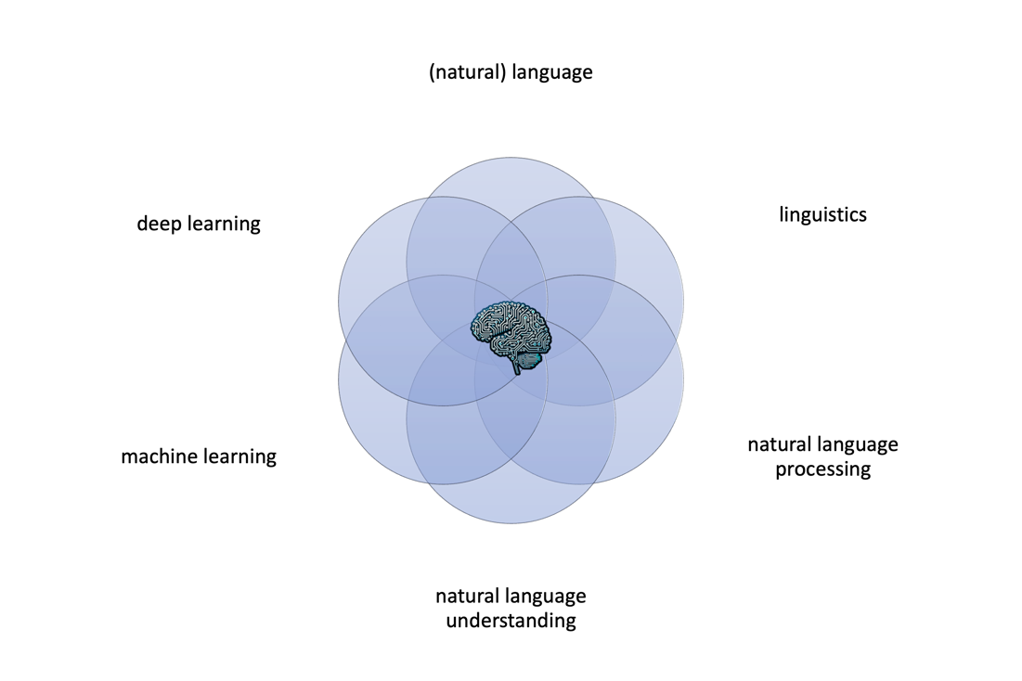
Figure 2: AI emergence across R&D from a variety of fields

The empirical foundations of these fields, and the technology that makes modern AI applications possible, is the underlying computational infrastructure, which is constructed off the foundations of Cloud Computing, processor innovation (e.g. GPU processors), and of course the telecommunications and networking infrastructure which is now so ever-present and ubiquitous that no one even considers it as an integral level of the technology stack. All of these advancements come together to provide the technological backbone upon which AI applications that effectively win the imitation game can be both developed and deployed and made accessible to hundreds of millions of users across the globe every day.

Adoption of this technology, along with its associated research both within academia and in industry, has dramatically accelerated in the last few years, mainly due to the applications mentioned above which have come to the market which represent the culmination of this research combined with the availability of computational power and network infrastructure which makes these applications possible.

These developments have given rise to NLP, and its close cousin Computational Linguistics, as new fields of study in and of themselves, each of which making significant contributions to the underlying technological advancements from which AI has emerged as one of, if not the, most impactful technological advancement in human history. These fields all rest on our understanding of the nature and structure of language and its relationship to computation, i.e. linguistics and computational linguistics, fields of study which also were revolutionized in the twentieth century, most notably by Noam Chomsky, but also, like any of the scientific fields in question, contributed to by hundreds of researchers across decades, all of which come together to illustrate the power of the scientific research and development community, and the process of scientific development itself, as it is compounded across time and disciplines. We look to build on that approach here as we try and make sense of the result of these scientific advancements.

Technically, NLP as a computer science discipline, consists of the tools, techniques, libraries, and algorithms that facilitate the ‘processing’ of natural language, this is precisely where the term natural language processing comes from. But it necessary to clarify that the purpose of the vast majority of these tools and techniques leverage machine learning (ML) techniques, a separate discipline and area of research in its own right that is derived from statistics and data analysis (Data Science), adapted for use in NLP and AI in conjunction with deep, neural networks (Deep Learning) to facilitate and advance the wide variety of powerful NLP tools in use today that underpin AI applications such as chat bots, search and information retrieval systems, recommendation engines, sentiment analysis and spam detection tools, and a wide variety of other AI applications.

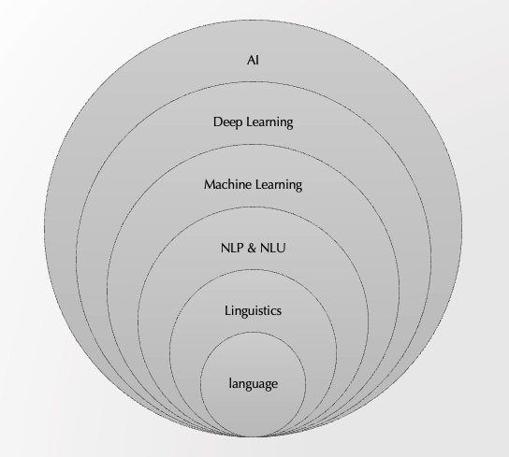
Figure 3: NLP, AI, and Computer Science

From a machine learning and deep learning perspective, NLP is just one domain of many that sits atop its mathematical, algorithmic and computational infrastructure which is predicated on the vectorization of data which is then fed into sophisticated machine learning models which use linear algebra and calculus and related mathematical techniques in order to effectively ‘learn’ – the two major methods being supervised, where the model is built and optimized with training data, and unsupervised which is fully automated and typically based upon mathematical analysis and derivations. By means of these machine learning techniques, which are pulled together into multiple neural network layers from which the field of deep learning has emerged, virtually all of modern AI applications in the NLP domain have emerged. As such one of the fundamental aspects of NLP as a discipline is the collection, parsing and transformation (representation) of textual (digital) input into data structures that machines can understand, a detailed review of which is the topic of this paper.

Natural Language Understanding (NLU)

GLUE benchmark

Language Theory

While the researchers and application developers in the NLP space leverage classic ML DL data structures and algorithms, they nonetheless – because of the nature of language itself – are confronted with specific unique challenges related specifically to the nature of language itself that they at least must be familiar with in order to apply ML and DL solutions to NLP problems. As such, terms that become not just relevant but elementary in understanding NLP algorithms and components are terms that come straight out of the field of linguistics, where context, morphology, syntax, and semantics have well defined meanings which correspond to certain data structures and/or processes within standard libraries that have been developed to solve for some of the very hard problems of NLP and which in turn now stand as the basis for future development – on the shoulders of giants and such.

In this world, semantics, syntax and morphology come together to determine the boundaries of various representations of language, language that is broken into sentences - from paragraphs and texts – which they themselves are broken into parts of speech, entity recognition and into other ‘parts of speech’ which in turn facilitate the ‘understanding’ of the machine to ultimately, and this is the ML part (which leverages DL design patterns), spit out optimal outcomes as defined within the context of the specific NLP application being developed – be it a support chatbot, a text summarization tool, an email spam filtering application, or one of a host of other modern day applications that are built using modern NLP technology on top of ML and/or DL models.

Natural Language Processing (NLP) and Natural Language Understanding (NLU) are subfields of artificial intelligence (AI) and computational linguistics that focus on the interaction between computers and human language. They involve the application of algorithms and models to understand, interpret, and generate human language in a way that is both meaningful and useful. Here's a detailed description of the underlying linguistic theory, key milestones, and relevant research in these fields.

- Syntax: The study of the rules that govern the structure of sentences. It includes the arrangement of words and phrases to create well-formed sentences in a language.
- Semantics: The study of meaning in language. It deals with how words and sentences convey meaning.
- Pragmatics: The study of how context influences the interpretation of meaning. It looks at how language is used in practice.
- Morphology: The study of the structure and form of words in a language, including the formation of words through prefixes, suffixes, and root words.
- Phonetics and Phonology: The study of the sounds of human speech (phonetics) and the systematic organization of sounds in languages (phonology).

Formal Grammar and Automata Theory

Noam Chomsky's theories on formal grammars and automata provided a foundation for computational models of language. Chomsky's hierarchy classifies languages based on their generative power and complexity (e.g., regular, context-free, context-sensitive grammars).

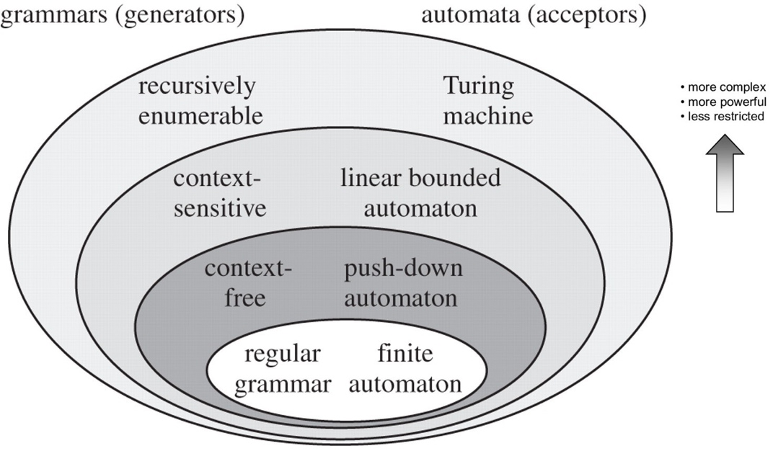
Figure 4: Chomsky's Hierarchy of Languages (Fitch, 2010)

Distributional Semantics:

Based on the idea that words appearing in similar contexts tend to have similar meanings. This theory underpins many vector space models of semantics, including Word2Vec.

Historical Context of NLP & NLU

One of the earliest examples of NLP was in the area of machine translation, demonstrated in the Georgetown-IBM Experiment in 1954 which illustrated some basic language translation capabilities between Russian and English (Hutchins, 2004). Research and funding into NLP was stymied somewhat in the 1960s with the publishing of the infamous ALPAC report, a study commissioned by US government scientific agencies on the efficacy and potential of NLP as a field of research, concluding that the preliminary results in machine translation (MT) research were unsatisfactory and did not justify further research and investment, (Pierce & Carroll, 1966).

Progress would not be thwarted however, and in the 1970s significant milestones were reached with the development of a simple AI agent that could manipulate shapes on a table and remember and store its actions, a precursor to modern robotics and AI agents (Winograd, 1972), and an early language understanding and reasoning agent called MARGIE (Schank, et al., 1973).

In the late 1980s to the early 2000s, statistical approaches gained prominence, with the introduction of methods such as Hidden Markov Models (HMMs) and Maximum Entropy models.

The resurgence of neural networks and deep learning since the mid-2000s revolutionized NLP, leading to significant breakthroughs in various tasks such as language modeling, machine translation, and sentiment analysis.

Early Years: 1950-1980

Alan Turing: In 1950, Turing’s seminal paper, “Computing Machinery and Intelligence,” introduced the idea of machines understanding and processing natural language, which laid the foundation for the field of artificial intelligence and computational linguistics.

Alan Turing's "Computing Machinery and Intelligence" (1950) posed the question of whether machines can think, introducing the Turing Test as a measure of AI's ability to exhibit intelligent behavior.

Noam Chomsky: Chomsky’s work on formal grammars, particularly his 1957 book “Syntactic Structures,” revolutionized the study of syntax and provided a formal framework for language that influenced early computational models.

Noam Chomsky's "Syntactic Structures" introduced phase-structure grammar, influencing computer understanding of language.

The development of early machine translation systems, such as the Georgetown-IBM experiment (1954), demonstrated rudimentary automatic translation.

Early attempts like the ELIZA program aimed to mimic human conversation using simple pattern matching.
Joseph Weizenbaum: Developed ELIZA in the mid-1960s, one of the first natural language processing programs, demonstrating the potential for human-computer interaction through text.
However, expectations weren't met, and funding was halted by the 1960s.
Introduction of rule-based systems and expert systems for language processing.
SHRDLU (1970) by Terry Winograd was an early NLU system that could understand and manipulate objects in a micro-world.

John McCarthy: Coined the term “Artificial Intelligence” and contributed significantly to early AI research, which encompassed natural language processing as a crucial component.

1970s-1980s: Rule-Based and Symbolic Approaches

Terry Winograd: His 1972 thesis, “Understanding Natural Language,” introduced the SHRDLU system, which could understand and manipulate objects in a micro-world through natural language commands.

Roger Schank: Developed conceptual dependency theory in the 1970s, which aimed to represent the meaning of sentences in a language-independent way.

Statistical & probabilistic (ML) Approaches: 1980s and 1990s

The field was revitalized with the introduction of statistical models replacing hand-crafted rules. IBM pioneered statistical machine translation models, and techniques like n-grams helped capture word patterns. Machine learning became prominent, with decision trees and probabilistic models ​ (DATAVERSITY).

1990s: Shift from rule-based to statistical methods, leveraging large corpora for language modeling. The introduction of the Hidden Markov Model (HMM) for part-of-speech tagging and speech recognition.

Frederick Jelinek: Pioneer in applying statistical methods to speech recognition at IBM, which led to significant advancements in the field.

Claude Shannon: Though his foundational work in information theory dates back to the 1940s, its implications for statistical language processing became increasingly recognized in this period.

Christopher Manning and Hinrich Schütze: Published “Foundations of Statistical Natural Language Processing” in 1999, which became a cornerstone for the field, providing comprehensive coverage of statistical methods in NLP.

Joshua Goodman: His work on various probabilistic models, including the Maximum Entropy model, has had a significant impact on NLP tasks like parsing and machine translation.

Deep Learning, Transformers & Modern NLP: 2000s-Present

Neural networks revolutionized the field, with feed-forward networks like word2vec capturing word relationships in dense vectors. Long Short-Term Memory (LSTM) models found their niche in processing sequences, while Transformer models (e.g., BERT, GPT) enabled contextual understanding and transfer learning. This period also saw pre-trained embeddings and large language models ​ (ar5iv)​.
The development of more sophisticated machine learning techniques, including Support Vector Machines (SVM) and Conditional Random Fields (CRF). Introduction of Latent Dirichlet Allocation (LDA) for topic modeling.
Text Pre-Processing and Embedding Techniques: Various text pre-processing steps like tokenization, noise removal, and word segmentation are crucial for cleaning and structuring raw data. Representations evolved from one-hot encoding and statistical-based embeddings to contextual models like ELMo and GPT-3. Comprehensive surveys highlight the transition from classical to modern-day techniques ​ (ar5iv)​​ (DATAVERSITY)​.

Geoffrey Hinton, Yann LeCun, Yoshua Bengio: Pioneers of deep learning whose methods transformed many areas of machine learning, including NLP. Their work on neural networks laid the groundwork for modern NLP models.
Tomas Mikolov: Developed Word2Vec in 2013, which significantly advanced the field by providing a method to represent words in continuous vector space, enabling better handling of semantic relationships.
Neural Networks & Autoencoders: Hinton and Salakhutdinov's paper "Reducing the Dimensionality of Data with Neural Networks" (2006) introduced deep autoencoders, paving the way for deep learning-based representation learning methods. Autoencoders are neural network architectures designed to learn efficient representations of input data by reconstructing it from a compressed representation.
Deep Learning: The resurgence of deep learning was fueled by breakthroughs such as AlexNet (Krizhevsky et al., 2012), which achieved unprecedented performance in image classification tasks, demonstrating the power of deep learning architectures in representation learning. Deep neural networks with multiple layers have shown remarkable capability in learning hierarchical representations of data, capturing complex patterns and abstractions.

2010s-Present: Transformer Models and Beyond

Vaswani et al.: Introduced the Transformer architecture in 2017 with the paper “Attention Is All You Need,” revolutionizing NLP by enabling models to process entire sentences at once rather than sequentially.
OpenAI and Google: Developed large-scale pre-trained language models such as GPT-3 and BERT, which have set new benchmarks in various NLP tasks.
Transfer Learning & Pre-Trained models: Pre-trained models like OpenAI's GPT (Generative Pre-trained Transformer) and Google's BERT (Bidirectional Encoder Representations from Transformers) have demonstrated the effectiveness of transfer learning in NLP tasks by learning general-purpose language representations from large-scale text corpora. Transfer learning leverages knowledge learned from one task or domain to improve performance on another, often related task or domain.

Key Papers & Milestones

- "Attention is All You Need" by Vaswani et al. (2017)
- "BERT: Pre-training of Deep Bidirectional Transformers for Language Understanding" by Devlin et al. (2018)
- "Language Models are Few-Shot Learners" by Brown et al. (2020)
- "BERTology Meets Biology: Interpreting Attention in Protein Language Models" by Schütze et al. (2021)
- "Linguistic Knowledge and Transferability of Contextual Representations" by Rogers et al. (2020)
- Turing, A. M. (1950). Computing Machinery and Intelligence. Mind, 59(236), 433-460.
- Chomsky, N. (1957). Syntactic Structures. Mouton.
- Manning, C. D., & Schütze, H. (1999). Foundations of Statistical Natural Language Processing. MIT Press.
- Vaswani, A., Shazeer, N., Parmar, N., et al. (2017). Attention Is All You Need. Advances in Neural Information Processing Systems, 30, 5998-6008.

- Word Embeddings: Techniques like Word2Vec (Mikolov et al., 2013) and GloVe (Pennington et al., 2014) revolutionized how words are represented in NLP, enabling algorithms to capture semantic relationships.
- Sequence-to-Sequence Models: The introduction of sequence-to-sequence models (Sutskever et al., 2014) paved the way for neural machine translation systems like Google's Neural Machine Translation (GNMT) (Wu et al., 2016).
- Attention Mechanism: The attention mechanism (Bahdanau et al., 2014) enhanced sequence-to-sequence models, allowing them to focus on relevant parts of the input sequence during decoding.
- Transformer Architecture: The Transformer architecture (Vaswani et al., 2017) eliminated the need for recurrence in sequence modeling, enabling parallelization and leading to models like BERT (Devlin et al., 2018) and GPT (Radford et al., 2018).

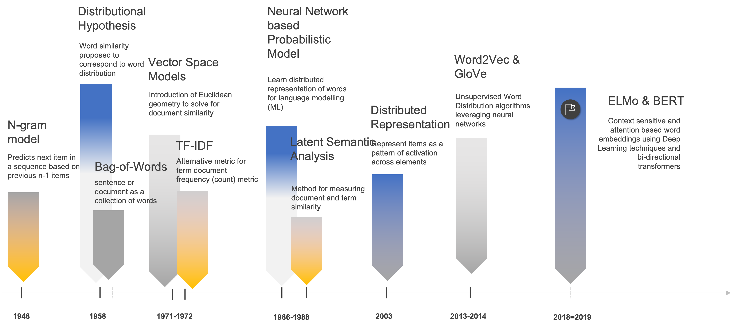
Figure 5: NLP R&D Timeline and Major Developments

Computational Linguistics

Computational Linguistics is an interdisciplinary field at the intersection of computer science and linguistics. It focuses on the use of computational methods to process and analyze human language. The goals of computational linguistics include understanding how natural languages work, developing algorithms to facilitate human-computer interaction, and building systems that can process and understand natural language effectively. Key areas of research include syntax, semantics, discourse, phonetics, and pragmatics, as well as the development of linguistic resources such as corpora and lexicons.

Key aspects of computational linguistics include:
- Theoretical Linguistics: Computational linguistics often involves applying linguistic theories to create formal language structure and behaviour models.
- Corpus Linguistics: The analysis of large bodies of text (corpora) to identify linguistic patterns and extract information for computational models.
- Development of Linguistic Resources: Creating lexicons, grammars, and other linguistic resources used in various language technology applications.

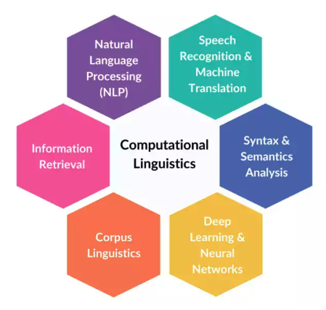
Figure 6: The field of Computational Linguistics

Key Activities in Computational Linguistics:

- Parsing: Techniques like context-free grammars (CFGs) and dependency parsing are used to analyze the syntactic structure of sentences. Dependency parsing focuses on the relationships between words, forming a tree structure.
- Semantic Parsing: Converts natural language into a formal representation of its meaning. Involves tasks like named entity recognition (NER), semantic role labeling (SRL), and entity linking.
- Linguistic Analysis: Developing computational models for understanding linguistic phenomena.
- Corpus Linguistics: Creating and analyzing large datasets of text or speech to study language use.
- Language Resources: Building databases of linguistic information, such as dictionaries and annotated corpora.
- Algorithm Development: Designing algorithms for tasks like parsing, machine translation, and information retrieval.
- Applications: Implementing linguistic knowledge in practical applications, such as spell checkers, speech recognition systems, and language learning tools.

Differences Between Computational Linguistics, NLP, and AI

NLP is a subfield of artificial intelligence that focuses on the interaction between computers and humans through natural language. It involves designing algorithms and systems that can understand, interpret, and generate human language. While computational linguistics often involves theoretical aspects and the development of linguistic resources, NLP is more application-oriented, aiming to solve practical problems such as machine translation, sentiment analysis, and chatbots.

Key Aspects of NLP:
- Text Processing: Techniques for tokenization, stemming, and lemmatization.
- Machine Translation: Systems that translate text or speech from one language to another.
- Sentiment Analysis: Identifying and extracting subjective information from text.
- Information Retrieval: Retrieving relevant information from large datasets.
- Speech Recognition and Synthesis: Converting spoken language to text and vice versa.

Artificial Intelligence (AI) is a broad field that encompasses the development of algorithms and systems capable of performing tasks that require human intelligence. AI includes various subfields such as machine learning, robotics, computer vision, and NLP. Computational linguistics and NLP are thus considered subfields within the broader AI domain. AI aims to create intelligent agents that can reason, learn, and interact with their environment.

Key Aspects of AI:
- Machine Learning: Algorithms that enable systems to learn from data.
- Robotics: Designing and building robots that can interact with the physical world.
- Computer Vision: Enabling machines to interpret and understand visual information.
- NLP: As a subfield, focusing on natural language understanding and generation.
- Cognitive Computing: Creating systems that simulate human thought processes.

Current Status

The field of computational linguistics today is characterized by the dominance of deep learning techniques, particularly transformer-based models. These models have achieved state-of-the-art performance in a wide range of tasks, including machine translation, sentiment analysis, question answering, and more. Key tools and frameworks like TensorFlow and PyTorch have made these models more accessible to researchers and practitioners.

Summary

- Computational Linguistics: Focuses on the computational study and modeling of linguistic phenomena, often involving theoretical and resource-building aspects.
- NLP: A practical subfield of AI that focuses on developing systems and algorithms for processing and understanding human language in real-world applications.
- AI: An overarching field that includes the development of intelligent systems capable of performing tasks that require human-like intelligence, encompassing various subfields, including NLP and machine learning.

In essence, computational linguistics provides the theoretical and linguistic foundation that informs the development of NLP technologies, while AI provides the broader context and methodologies within which NLP operates.

Modern NLP & AI Applications

leverages speech recognition and text to speech technology which feeds language into NLP applications for parsing, analysis and processing such that an integrated application like Siri or Alexa can come to life so to speak, and provide useful capabilities that are now very well integrated into our home, our cars and even our mobile devices.

NLP as a field of research is focused on enabling computers to understand, interpret, and generate human language, focused on the computation and (information) processing related to language, primarily in digital form but also including audio (and video) processing of language as well, through applications such as speech recognition and text-to-speech applications that are core to many of the speaking / voice-driven (AI) assistants or agents that we are familiar with.

Functionally, the NLP field is understood as consisting of two inter-related but functionally and technically distinct sub-domains - a processing part which deals with the parsing and syntactic (structural) analysis of the language NLP, which includes sub-domains such as named entity recognition (NER), part-of-speech (POS) tagging, stemming & lemmatization, and other aspects of the processing, parsing and delineation of the components of language (broadly syntax from a linguistic perspective), and the understanding part (NLU) which includes sub-domains such as relation extraction, semantic parsing, sentiment analysis, summarization, question & answering, language representation, and other aspects of NLP that have to do with making sense of language (broadly semantics from a linguistics perspective).

It is advancements in NLP that have led directly to the development of AI agents, or chatbots, which have captured the public’s imagination as of late such as ChatGPT and countless others that have transformed the digital information processing landscape as much as the Internet did in the mid to late 1990s, creating a surge of investment and applications that are driving innovation across a wide variety of industries and also driving changes in the compliance, legal and regulatory landscape as well as legislators across the world grapple with what to do with such a ground breaking technology.

NLP applications are ubiquitous now, perhaps the most prolific of which is Search, or information retrieval as it is termed in Computer Science (CS) and Artificial Intelligence (AI) research circles. Search, arguably one of the most transformative technological advancements since the commercial adoption of the Internet in the 1990s, is an application design pattern that is rooted in NLP research and can be found in almost every application nowadays, to the point where applications are severely hindered if they have no search capability. But core NLP research and development in the last few decades has also led to technological advancements in applications such as chatbots or virtual assistants, product reviews and recommendations, document summarization and categorization, as well as spam filtering and fraud detection.

All of these applications, and the underlying ‘intelligence’ that underpins them, is based more or less upon advancements in NLP that have in many respects underpinned the technological breakthroughs that are hallmarks of the digital era. All of these applications rely on the ability of a machine to understand natural language (hence the term ‘natural language processing’) and our ability from a research perspective to devise techniques to facilitate the development of these NLP based applications, in an unsupervised manner at massive scale, has been arguably one of the driving forces for productivity and usability increases across the application landscape in the last decade, both for the consumer as well as the business and for the mobile as well as desktop and server sides of the application market.

In this context, NLP can be understood from a workflow or data processing perspective which starts with raw text, or the corpus which is the term used in the literature, to which various transformation, normalization and standardization techniques are applied (such as parts of speech mapping, tokenization, and stop word removal) which culminate in the output of data structures that are optimized for various ML tasks, with the data structures themselves of course optimized for the specific type of NLP application being developed or researched.

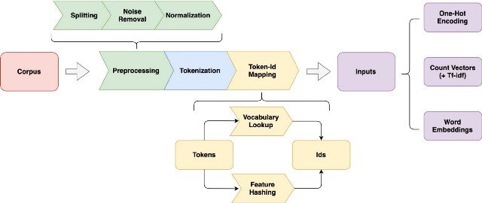
Figure 7: Typical NLP Text Pipeline

For example, if we are translating texts we need to work with words but if we are summarizing text we may want to work with sentences or a series of words, or n-grams as they are typically referred to, and each of these types of inputs require and necessitate different forms of output that are ultimately fed into the ML or DL model that is presumably doing something useful from a predictive or analytical perspective. These preprocessing, cleansing and normalization steps that are applied to the natural language, i.e. the text or corpus, before it can be worked with for learning are fundamental to NLP, without which machines would not be able to learn nearly as well as they do in practice. In almost all modern NLP applications, the output of this preprocessing or data transformation pipeline takes the form of vectors of real numbers that are mathematical computed based upon some fundamental linguistic (theoretical) properties called word embeddings, the specific technological advancement that is the subject herein. We call these data structures representations of the text, and while they are typically constructed and associated with words, sometimes they are associated with sentences, groups of words or n-grams, or even documents or sets of sentences or phrases.

Current Areas of Research & Development

- Pre-trained Language Models: Large-scale pre-trained language models, such as BERT, GPT, and their variants, continue to be a major focus. Recent developments include models like T5 (Raffel et al., 2019) and GPT-3 (Brown et al., 2020).
- Multimodal NLP: Integrating language with other types of data, such as images and videos, to create more comprehensive AI systems. Integrating multiple modalities such as text, images, and audio in NLP tasks is an emerging area of research. Models like CLIP (Radford et al., 2021) and UniViLM (Qi et al., 2020) address this challenge.
- Few-Shot and Zero-Shot Learning: Techniques that enable NLP models to generalize to unseen tasks or domains with limited training data are actively researched. Meta-learning approaches and prompt-based methods are notable in this area (Schick and Schütze, 2020; Brown et al., 2020).
- Ethical and Fair NLP: Addressing biases in language models and ensuring fair and ethical use of NLP technologies. With the increasing impact of NLP on society, research on fairness, bias mitigation, and ethical considerations in NLP models and applications is gaining traction (Bender and Friedman, 2018; Gehman et al., 2020).
- Low-Resource Languages: Developing models and methods that work well for languages with limited available data.
- Explainability: Improving the interpretability and transparency of complex NLP models to build trust and understanding.
- Human-AI Collaboration: Enhancing the ability of AI systems to work alongside humans in various applications, from education to healthcare.

Summary

These developments represent a diverse array of approaches and techniques in representation learning across different domains of AI. While these methods have significantly advanced the field, ongoing research continues to explore new architectures, algorithms, and applications of representation learning.

These developments highlight the evolution of NLP from rule-based and statistical methods to deep learning paradigms, with ongoing research focusing on advancing pre-trained models, multimodal understanding, few-shot learning, and ethical considerations

In summary, NLP's journey has seen shifts from handcrafted grammar rules to sophisticated neural architectures that can now understand and generate text more naturally, a testament to decades of interdisciplinary research and technological innovation.

Language Representation in NLP & AI

One of the key foundational representation elements in NLP is the notion of vector space models and word embeddings, two very much interrelated ideas that are fundamental to almost all of the modern LLMs and their predecessors which have revolutionized the field of AI the in the last two decades. To understand how it is that these word embeddings are constructed, trained from text really, and what an underlying vector space models is and why it is relevant to NLP solves, it’s necessary to start from the ground up so to speak and look at the text representation methods and training techniques used to build these models.

Generally, the process of learning the representation of text is referred to as representation learning which although applicable to machine learning generally consists of very specific techniques that are effective in NLP. In this context, representation learning involves the task of learning efficient, meaningful representations of words, phrases, sentences, or documents that can then be used for various downstream NLP tasks such as sentiment analysis, machine translation, question answering, and other NLP solves.

The process of representation learning is a fundamental concept in artificial intelligence (AI) that involves automatically discovering and learning useful representations of data, often in a lower dimensional space to be used by ML and DL algorithms, which are designed to capture, really encode, meaningful features and/or characteristics of the data in a structured and compact form, enabling effective learning and reasoning of the underlying data.

Representation learning and word embeddings are closely related topics in NLP and the vast majority of research literature devoted to representation learning in NLP in the last few decades has been focused on designing word embeddings which encode this information.

Feature Selection in Semantic (Vector) Space

In any ML model, one of the most critical aspects of model construction is the process of identifying the most important and salient features, or inputs, that are both necessary and sufficient for the model to be effective. This concept, referred to as feature selection in the AI, ML and DL literature, is true of all ML/DL based applications and NLP is most certainly no exception here. The goal of feature selection is to hone the number of features down to the most elemental level while not losing any of the granularity or color of the overall model that is reflected on the various features, or inputs, which drive the learning model in question – effectively balancing computational performance against model predictability as it were.

In the NLP domain, given that the feature set is typically the dictionary size of the vocabulary in use, this problem is very acute and as such much of the research in NLP in the last few decades has been solving for this very problem and word embeddings in particular as a form of language (really word or token) representation represents the most modern solution to this problem. Word embeddings effectively reduce the representation of a word - or again a token or in some cases subword or even character – to a fixed size vector of real numbers. This is a very convenient form of representation for these fundamental linguistic, or textual, elements, one that is easily consumed by ML and DL models in the NLP space and one that addresses this curse of dimensionality problem which underlies NLP more broadly.

In classical physics we deal (mostly) with four dimensions - three in Euclidean (or Cartesian) space and a fourth dimension of time – while with ML problems we are operating in dimensional space which is defined by the set of features in our model (usually denoted by X), where dimension sizes of 100 or even sometimes 1000 are quite normal given how ubiquitous data is in the modern, Internet era. With the increase in dimensional complexity though comes a geometrically (if not exponentially) increase in computational resource requirements, a problem called the curse of dimensionality in ML and AI circles. In the NLP domain this problem is exacerbated by the fact that the feature set for some of the problem domains (like for example predictive text, chatbots, virtual assistants or language translation) can be almost the size of the language dictionary itself.

This curse of dimensionality, which the NLP domain is in particular is challenged with, has driven a significant amount of research into this particular aspect of ML, i.e. feature selection, which is basically the process of identifying the most important, or most relevant, set of features in a given model or problem domain such that the applications that are developed can effectively run in a reasonable time with a reasonable amount of computing resources. As such, much of the research in NLP in the last few decades, and many of the breakthroughs in terms of application performance and effectiveness (accuracy), have been in the area of encoding, or compressing, information related to various forms of language - words, phrases, n-grams, sentences or documents – to condense information, ultimately semantic information, into data structures (vectors, matrices) that machines can process efficiently, i.e. learn efficiently from – aka NLP feature selection. Again, this part of NLP application development can be understood as a projection of the natural language, i.e. the input text itself, into a fixed dimensional feature space, a process that is both necessary and fundamental to the solving of any and all machine learning problems and is especially significant in NLP.

This challenge of dealing with the sparsity of language data in vectorized form, which again is fundamental to the problem of machine learning and AI more generally, goes back to the 1980s with the advancement of techniques such as Vector Space Models (VSMs) and Latent Semantic Analysis (LSA) as well as random indexing, all techniques that were designed to convert sparse data and compress it for more efficient computation within the context of machine learning applications, i.e. dimension reduction or feature selection techniques. In 2000, neural networks were introduced into the problem domain to solve for some the same problems and eventually these techniques evolved into word embeddings which have the unique quality of being able to be self-generated, i.e. automatically generated using unsupervised learning methods, and which are a way of representing semantic information, or meaning, in a non-sparse way.

One of the fundamental tenets of linguistics that has been well established since the middle of the last century is the idea that the meaning of a word can be understood by not just the context within which it is found (or heard as the case may be) but that generally, over a large corpus of text, or a large sampling of language as the case may be, that words found within a similar context should in most cases have similar meanings, leading to the now oft-used and famed expression in both linguistics and NLP circles that a word can be characterized, or understood in some sense, by the company it keeps. This is known in linguistics as well as NLP circles as the distributional hypothesis and it is this tenet that underpins many of the techniques described here which fall under the heading of word embeddings. It's upon this notion, the distributional hypothesis, that much of the semantic work in NLP is based, in particular as it relates to text vectorization and word embeddings, the topic of this paper. The idea being that if we can associate with a given work certain metrics that correlate to the word’s distribution throughout a given text or corpus, words that have similar meanings should in turn have similar distributional properties, i.e. are surrounded by similar words, throughout a given textual corpus.

In order to understand the information that ultimately comes to be stored and associated with a given word or token for a given text, it’s necessary to understand how it is that these ‘embedding’ structures are computed. This process, sometimes referred to as text vectorization, however can (and really should) be understood as a projection of the text, or tokens, into what we can be understood as a semantic space, a vector space of relative meaning that is calculated based upon the notion that words that are found in similar contexts, i.e. surrounded by similar words, have similar meanings – a notion in the linguistics world that is known as the distributional hypothesis, one of the most profound and yet simple concepts that underpins the effectiveness of LLMs in NLP and AI.

While one-hot encoding and count vector (Bag of Words) representations of text allow for the comparison of words in sentences, documents and sets of documents, they don’t store information related to the context of a given word, or sentence, within a given document, or corpus – such context is necessary for example when developing (ML/NLP) applications that solve for sentiment analysis, (machine) translation, or question-answering (chatbots or IVR) problems. These techniques also suffer from the fact that their number of dimensions (cf. curse of dimensionality), the semantic spatial boundaries you could call it, where the number of features or dimensions of the model is a function of the overall dictionary for the corpus at hand being analyzed. This becomes very cumbersome for ML generally given that the performance of a given model is a function of the feature set that is being analyzed and in this case the feature set is the scope of words being used, with each word in the set being associated with a vector that is sized based upon the total word count.

These Vector Space Models as they are sometimes called, originated as far back as in the 1970s, their design attributed to Gerard Salton who developed and documented a system called SMART in the early 1970s (Salton, 1971), granting him the moniker in some circles as the father of Information Retrieval. With SMART, Salton introduced the notion of Vector Space Models (VSMs) as a form of text representation to support the computation of document similarity and information retrieval, much of which provides the foundations for modern search systems. This model, along with the introduction of tf-idf as a statistical method for computing document terms across a given corpus (Sparck Jones, 1972), transformed the NLP landscape and opened the door for scalable and effective digital systems of information retrieval.

More formally, a vector space is described for a given vocabulary V, and a set of words w, where for each w $∈$ V, there is an associated vector $\vec{v_{w}}∈R^{d}$, where d is the fixed number of dimensions for the underlying vector space, effectively bounding the number of features that we use for our NLP model. Given that word embeddings are really vectors in an underlying multi-dimensional vector space, they inherit mathematical properties which are a function of the underlying space (geometry) within which they live - a vector space which is the primary dwelling place studied in linear algebra, governing the behavior and properties of word vectors, denoted as $\vec{v_{w}},$which live is such a space. Vector spaces, once initialized for a given semantic space that is learned from text, support the following properties:

- Vector Addition and Scalar Multiplication: The vector space must be closed under vector addition and scalar multiplication. This means for any vectors $\vec{\vec{v}},\vec{w}$ in the space, and any scalar $α$, the vector $\vec{v}+\vec{w}$ as well as $α\vec{v}$ are also in the space.
- Associativity and Commutativity of Addition: Vector addition is associative, meaning $\left(\vec{v}+\vec{w}\right)+\vec{u}=\vec{v}+\left(\vec{w}+\vec{u}\right)$, and commutative, meaning $\vec{v}+\vec{w}=\vec{w}+\vec{v}$.
- Distributivity of Scalar Multiplication with respect to Vector Addition: Scalar multiplication is distributive over vector addition, both from the left, $α\left(\vec{v}+\vec{w}\right)=α\vec{v}+α\vec{w}$, and from the right, $\left(α+β\right)\vec{v}=α\vec{v}+β\vec{v}$.
- Existence of Zero Vector: There exists a zero vector $\vec{0}$ in the space such that $\vec{v}+\vec{0}=\vec{v}$ for any vector $\vec{v}$.
- Existence of Additive Inverses: For every vector $\vec{v}$, there exists an inverse −$\vec{v}$ such that $\vec{v}+\left(-\vec{v}\right)=\vec{0}$
- Dimensionality: The vector space is finite-dimensional, where the number of dimensions is denoted by d, where d $∈N$ and is characterized by a set of basis vectors. The dimensionality d of the space is the number of vectors in any basis for the space, which corresponds to the number of features or coordinates each word vector has.
- Inner Product: Often, an inner product (or dot product) is defined on the space, enabling the measurement of angles and lengths. This is fundamental in calculating similarities between vectors, which is typically done using cosine similarity in these semantic spaces.
- Norm: Associated with the inner product, the norm of a vector $∥\vec{v}∥$ is defined, typically as $\sqrt{\vec{v}⋅\vec{v}}$​. This allows for the measurement of the magnitude of vectors and normalization of vectors.

These properties not only define the theoretical mathematical framework in which word embeddings operate but also provide the tools necessary for practical operations such as finding similar words, analogies, or clustering words based on their vector representations. This space mathematically bounds both the problem domain as well as the solution domain, and with word embeddings in particular, a modern variant of text vectorization, the dimensions are actually learned by the model itself in in order to ensure that the model exhibits certain properties, properties which are a function of what is known as the distribution hypothesis, more on this below.

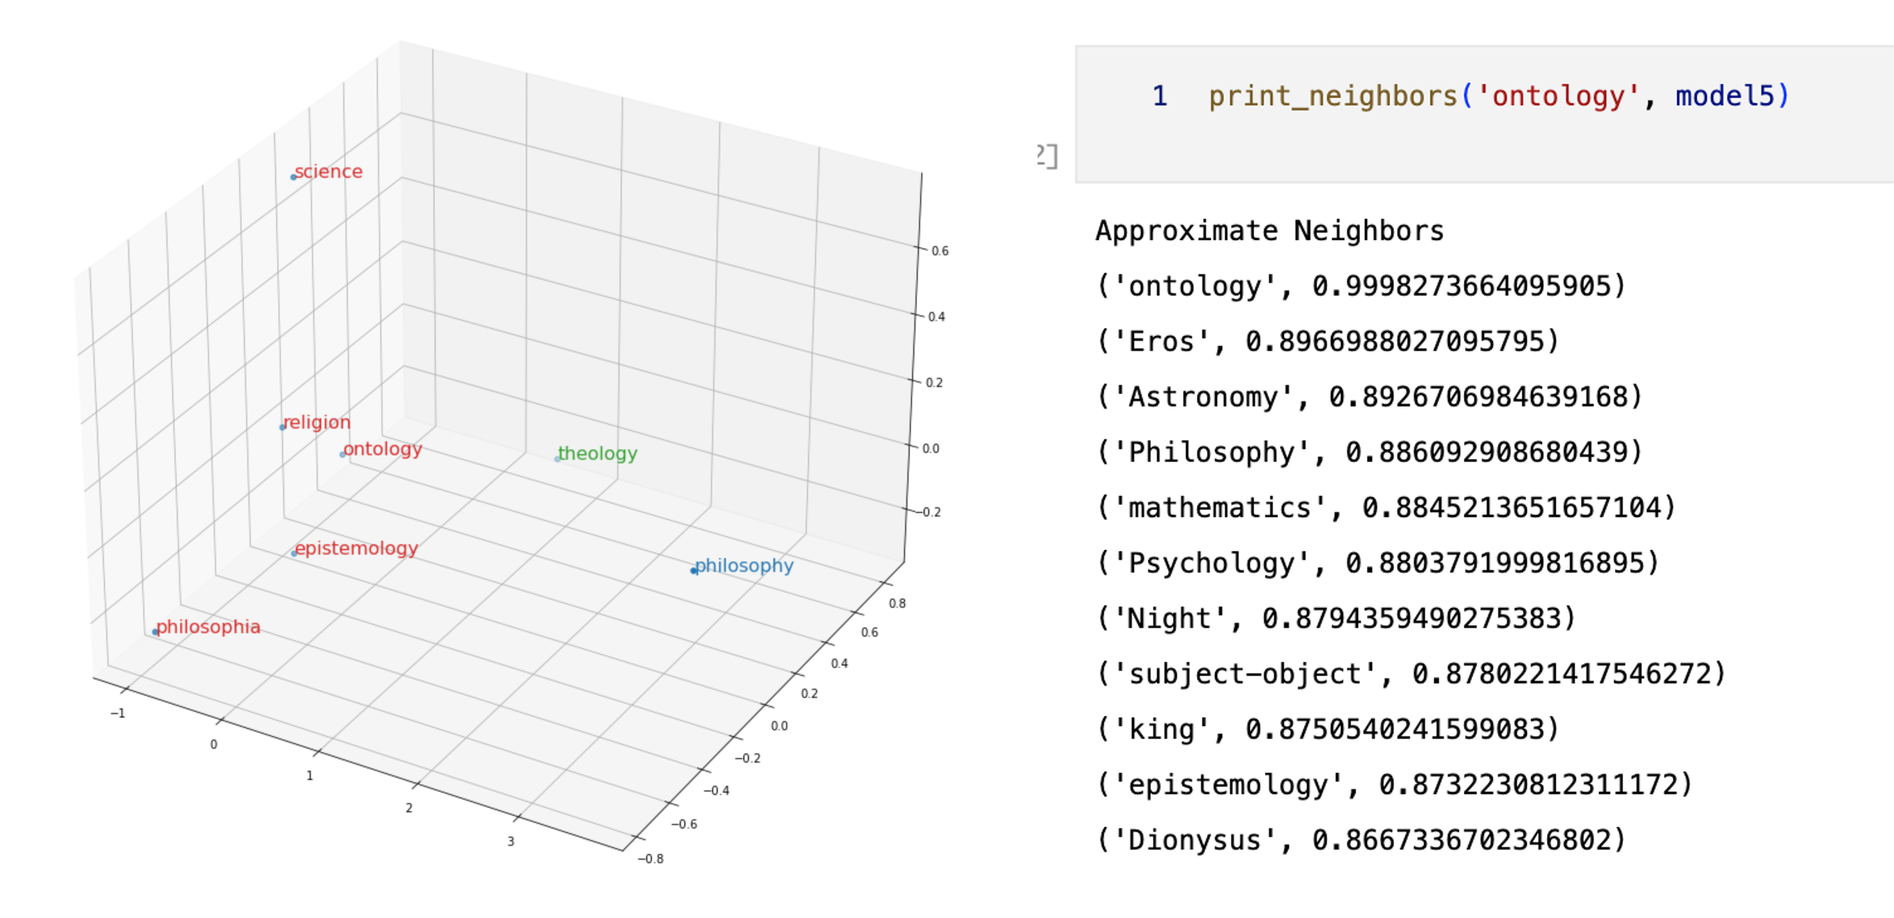
Figure 8: Semantic Space and Word Similarity

Latent Semantic Analysis or Latent Semantic Indexing

A related method for the calculation of document similarity, which also leverages the representation of text, and documents, in vector spaces, was created in the late 1980s called Latent Semantic Analysis (LSA), also referred to as Latent Semantic Indexing (LSI) within the context of Information Retrieval. LSA / LSI identifies latent contextual, or semantic, relationships between words by using singular value decomposition (SVD), a method of eigendecomposition of square matrices that can be applied to term-document matrices and information retrieval (Deerwester, et al., 1990).

From linear algebra we know that Singular Value Decomposition (SVD) is a factorization of a real or complex matrix that generalizes the eigendecomposition of a square normal matrix to any m × n matrix via an extension of the polar decomposition. Mathematically, if we have an m × n matrix (A), the singular value decomposition (SVD) of said matrix is a factorization of the form:

A = UΣV∗
where:
- U is an m × m orthogonal (or unitary, if complex) matrix,
- Σ is an m × n diagonal matrix with non-negative real numbers on the diagonal,
- V is an n ×n orthogonal (or unitary, if complex) matrix, and
- V∗ denotes the conjugate transpose of V (the transpose if V is real).

So then from linear algebra we know that there exists a decomposition of a matrix A into orthogonal matrices U and V, as a function of a specific diagonal matrix denoted as Σ, a technique that can be used to find latent similarities between documents in a corpus and leveraged to compute document (cosine) similarity, a factorization that is illustrated in the figure below and which can be used to identify latent


Figure 9: Latent Semantic Indexing using Singular Value Decomposition (Patel, 2019)

Geometrically, the factorization can be understood as a series of scaling and rotation transformations on the source matrix (M in this case) in multi-dimensional Euclidean space, as illustrated in the figure below.

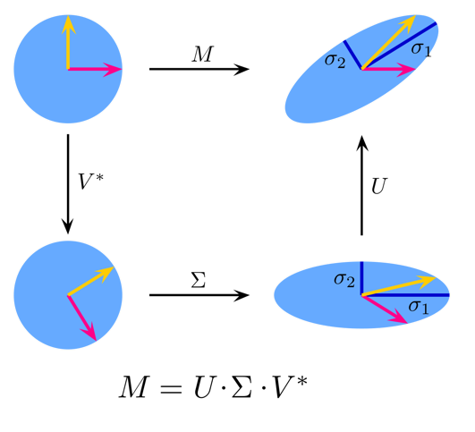
Figure 10: SVD in terms of scaling and rotation of vectors in Euclidean space


Figure 11: document query in vector space

The Distributional Hypothesis & Word Embeddings

Approaches such as VSMs or LSI/LSA are sometimes as distributional semantics and they cross a variety of fields and disciplines from computer science to artificial intelligence, certainly to NLP, but also to cognitive science and even psychology. The methods, which are rooted in linguistic theory, use mathematical techniques to identify and compute similarities between linguistic terms based upon their distributional properties, with again TF-IDF as an example metric that can be leveraged for this purpose. In this context, these methods which began as VSMs combined with or supplemented by LSI or LSA, have evolved into what we call in NLP research circles today as word embeddings, a semantically encoded (in vector space) representation of words, documents or terms based upon the premise that a given word’s meaning can be understood by its context, or in more vernacular terms, the company it keeps, i.e. what is known as the distributional hypothesis, an idea popularized by John Firth in the 1950s who coined the phrase ‘you shall know a word by the company it keeps’, i.e. that words found within a similar context should in most cases have similar meanings, the basic underlying principle behind the architecture, and effectiveness, of word embeddings.

Some of the simplest forms of text vectorization include one-hot encoding and count vectors (or bag of words), techniques. These techniques simply encode a given word against a backdrop of dictionary set of words, typically using a simple count metric (number of times a word shows up in a given document for example). More advanced frequency metrics are also sometimes used however, such that the given ‘relevance’ for a term or word is not simply a reflection of its frequency, but its relative frequency across a corpus of documents. TF-IFD, or term frequency-inverse document frequency, whose mathematical formulation is provided below, is one of the most common metrics used in this capacity, with the basic count divided over the number of documents the word or phrase shows up in, scaled logarithmically.

While one-hot encoding and count vector (Bag of Words) representations of text allow for the comparison of words in sentences, documents and sets of documents, they don’t store information related to the context of a given word, or sentence, within a given document, or corpus – such context is necessary for example when developing (ML/NLP) applications that solve for sentiment analysis, (machine) translation, or question- answering (chatbots or IVR) problems. These techniques also suffer from the fact that their number of dimensions (cf. curse of dimensionality), the semantic spatial boundaries you could call it, where the number of features or dimensions of the model is a function of the overall dictionary for the corpus at hand being analyzed. This becomes very cumbersome for ML generally given that the performance of a given model is a function of the feature set that is being analyzed and in this case the feature set is the scope of words being used, with each word in the set being associated with a vector that is sized based upon the total word count.

While these internal (text) representations come in a variety of forms, each form being optimized for a specific task or specific type of ML model for a given (NLP) application (and sometimes are used together to form a multi-dimensional view of the ‘language’ that is being ‘processed’), generally however, given the propensity of machines to be efficient at computing numbers (scalers), vectors and matrices (tensors), they involve a conversion of text data into some vector of scalers (or reals), where in a mathematical sense the ‘feature space’ is bound by a relevant and impactful (predictive) number of dimensions that can then be used for efficient computation.

Some of the simplest forms of text vectorization include one-hot encoding and count vectors (or bag of words), techniques. These techniques simply encode a given word against a backdrop of dictionary set of words, typically using a simple count metric (number of times a word shows up in a given document for example). More advanced frequency metrics are also sometimes used however, such that the given ‘relevance’ for a term or word is not simply a reflection of its frequency, but its relative frequency across a corpus of documents. TF-IFD, or term frequency-inverse document frequency, whose mathematical formulation is provided below, is one of the most common metrics used in this capacity, with the basic count divided over the number of documents the word or phrase shows up in, scaled logarithmically.

More advanced forms of word embeddings evolved against the backdrop of these simpler mechanisms for representing terms, words or n-grams, designed specifically to answer questions about semantic similarity which is a key requirement in search applications, or Information Retrieval as it is called in research circles. For example, in a given Google search, one is trying to determine as accurately or ‘closely’ as possible, what documents are as closely related to the given search query that is input by a given user. This application requirement can be conceived of, from a software or NLP perspective, as solving for word, phrase or sentence similarity, for if you can identify which documents are most similar to your search input, you now have an effective way to rank order search results.

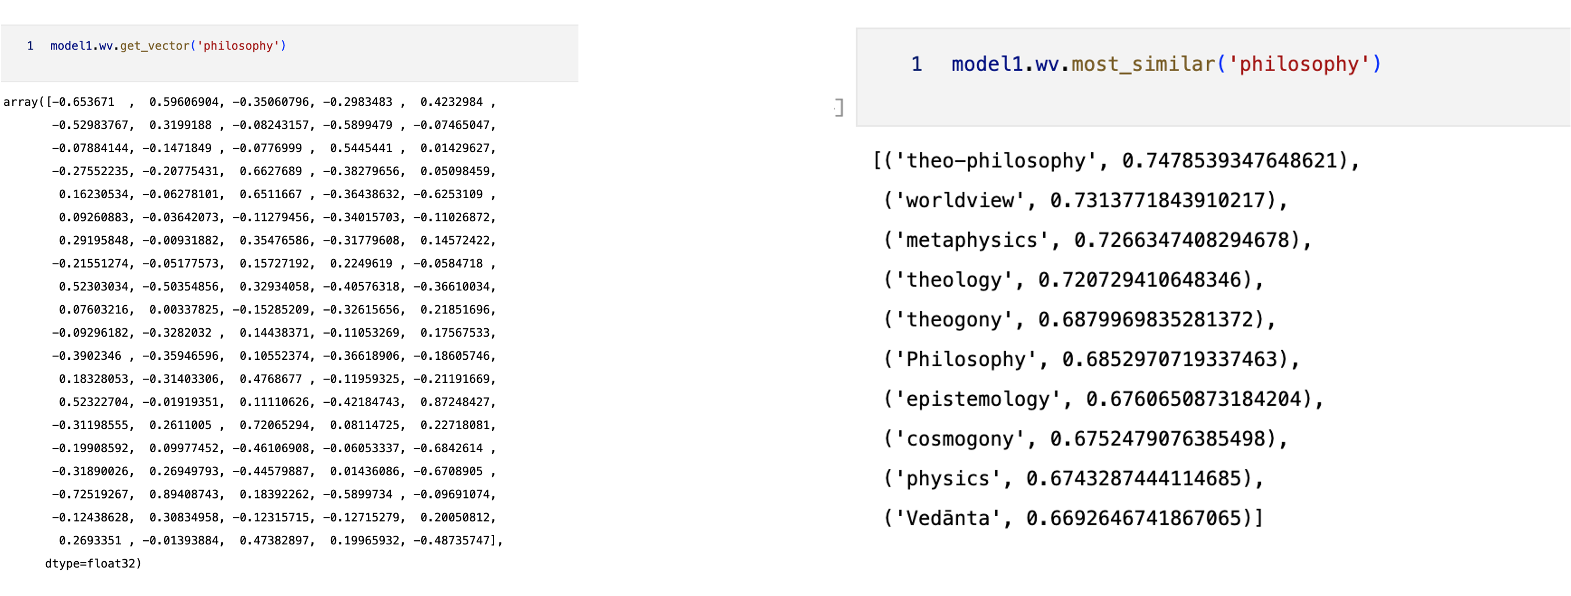
Figure 13: Word Embeddings & Similarity Vectors

This approach however relies on a certain (set of) linguistic theories which then in turn are formulated mathematically, or more precisely statistically, in an area of research and development that is sometimes referred to as distributional semantics, where similarities between linguistic terms are derived from the distributional properties of the underlying terms. In this context, word embeddings can be understood as semantic representations of a given word or term in a given textual corpus. At their core then, word embeddings can be understood as a set of mathematically (statistically) generated (real) numbers, attributes or features within the context of ML, that are created from a body of text which map a given word into a semantic space for a given domain which follows from the distribution hypothesis, namely that words that are found in similar contexts have similar meanings, such that word, phrase or even document similarity can be efficiently computed. Semantic spaces are the geometric structures within which these problems can be efficiently solved for.

The more modern variants of word embeddings have mostly been developed by big tech companies, with Word2Vec introduced by Google in 2013 in the seminal paper ““Efficient Estimation of Word Representations in Vector Space” (Mikolov, et al., 2013), followed closely thereafter by the introduction of “GloVe: Global Vectors for Word Representation” by the Stanford NLP lab in 2014 (Pennington, et al., 2014), and then more sophisticated methods introduced in 2018 and 2019 in succession, namely ELMo which was introduced with the paper “Deep contextualized word representations“ which came out of the (Paul) Allen Institute for Artificial Intelligence (Peters, et al., 2018), and then BERT, also out of Google AI labs, introduced in the 2019 paper “BERT: Pre-training of Deep Bidirectional Transformers for Language Understanding” (Devlin, et al., 2019). The most profound innovation with respect to word embeddings however, and the underlying architecture for almost all modern variants language models in fact, is the transformer based architecture which was introduced in 2017 (also out of Google AI labs) in the famous paper, “Attention is All You Need” (Vaswani, et al., 2017), all of which map words as vectors in Euclidean space in order to represent meaning, i.e. semantic space embeddings effectively.

While these internal (text) representations come in a variety of forms, each form being optimized for a specific task or specific type of ML model for a given (NLP) application (and sometimes are used together to form a multi-dimensional view of the ‘language’ that is being ‘processed’), generally however, given the propensity of machines to be efficient at computing numbers (scalers), vectors and matrices (tensors), they involve a conversion of text data into some vector of scalers (or reals), where in a mathematical sense the ‘feature space’ is bound by a relevant and impactful (predictive) number of dimensions that can then be used for efficient computation. There are various methods for doing this, the most popular of which are covered in this paper – one-hot encoding, Bag of Words or Count Vectors, TF-IDF metrics, and the more modern variants developed by the big tech companies such as Word2Vec, GloVe, ELMo and BERT. Regardless of vectorization technique used, in other words which word embedding algorithm is selected, these pre-computed text vectors which encode a specific kind of semantic information can then be fed into various ML or DL models for actual NLP application development - such as again performing some sort of sentiment analysis or keyword generation, or in more complex examples like chatbots or language translation.

Tokenization

In order to relay appreciate the sophistication and level of semantic granularity encapsulated in Word2Vec (and word embeddings more generally) however, it’s necessary to have at least some knowledge of the underlying structures which feed this model, starting with the most basic of which maps input text into a vector(s) for machine learning. Machine learning algorithms, which are fundamental to the creation of word embeddings and vector space models, work with numbers – vectors and/or matrices of numbers – and therefore the first step in preparing text for Word2Vec, as with any other ML algorithm designed for the processing of text, is to convert the text into a vector of numbers, where each element of the vector represents a word, or a token.

A key to the effectiveness, and granularity, of these language models is determined by how it is that a given model defines a token, the simplest of which is as a word – or a one-to-one correspondence between a word and a token. Another option is by character, which represents words as a series of tokens, and a third option is a somewhere in the middle of these two, by subwords, which basically breaks apart words into components and treats each part a distinct token.

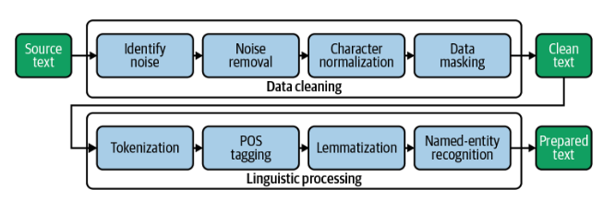
Figure 14: Typical NLP Pipeline (Albrecht, et al., 2020)

A token is a fundamental element that is produced as part of the preprocessing step of any NLP application, steps which come together in what is referred to typically as an NLP pipeline – with the source text, which consists of documents which come together and are grouped as a corpus, feed the pipeline and are cleansed and parsed to produce clean text, which then in turn can be tokenized, tagged, and/or lemmatized as necessary to feed downstream ML tasks.

It’s very important to recognize that this process is very much specific not only to the corpus and doc set that feeds the pipeline, which of course determines the steps necessary to ‘clean’ the input text for the model, but also that the underlying target language is a major determining factor in the linguistic parsing aspects of the NLP pipeline. For example, the steps and methods that are used to parse English text into tokens, POS (parts of speech), and lemmas (root form of words) is of course very different from the process of producing the same artifacts for Traditional Chinese for example, which of course is built from an entirely different set of symbols and characters and has a different grammatical and syntactic structure.

Regardless of vectorization or tokenization technique used however, in other words which word embedding algorithm is selected, these pre-computed text vectors which encode a specific kind of semantic information can then be fed into various ML or DL models for actual NLP application development - such as again performing some sort of sentiment analysis or keyword generation, or in more complex examples like chatbots or language translation.

Word2Vec

One of the major breakthroughs in word embedding technology came in 2013 when a team at Google led by Tomas Mikolov created Word2Vec (Mikolov et al 2013), a word embedding solution that uses (unsupervised) deep learning techniques to capture word associations from a large corpus of text leveraging both (continuous) bag of words as well as skip gram approaches to defining word context (semantics). When setting up the word embedding structure, we tell the model only how big we want the vector to be for each word (maybe between 50, 100, 200 or 300 for example), and let the model learn all the weights as well as the associated terms for said work, or token, again given context. As a result of such modeling, we can identify for example, words of similar meaning by looking at how close they are in the underlying vector space of words that is generated from the given text.

The most basic and fundamental of these models is Word2Vec (Mikolov, et al., 2013), and while it is not nearly as sophisticated as some of the other models we will discuss in this work (BERT, GPT, etc.) it nonetheless illustrates how it is that representations of language are constructed and used in NLP and AI and includes almost all of the fundamental architectural components of the forms of language representation that are used in more advanced models and as such serves as a very good working example as to how these structures are constructed, how they are used, and ultimately why it is that they are so effective at NLP solves in general.

There are two ways which the algorithm can be coded to learn the vector feature, or parameter values, one based on what is called the continuous bag of words model and another based on a continuous skip gram model, with the former method learning the embedding by predicting the current word based on context (or place) within the text, and the latter model predicting surrounding words based on a given current word. Both methods contextualize a given word that is being analyzed by using this notion of a sliding window, which is a fancy term that specifies the number of words to look at when performing a calculation basically. The size of the window however, has a significant effect on the overall model as measured in which words are deemed most ‘similar’, ie closer in the defined vector space. Larger sliding windows produce more topical, or subject based, contextual spaces whereas smaller windows produce more functional, or syntactical word similarities – as one might expect.

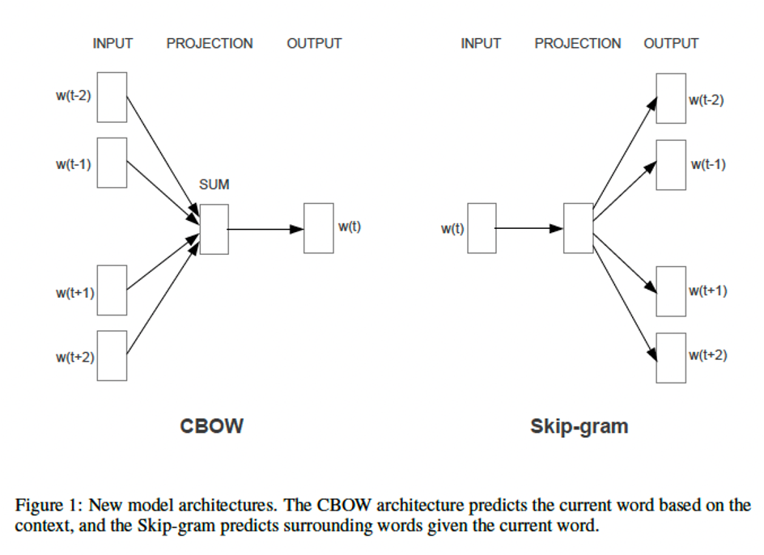
Figure 16: Word2Vec algorithmic design

Word2Vec is trained on the Google News Dataset on about 100 billion words and supports both word similarity as well as word prediction capabilities and as such has applicability in a variety of NLP applications such as Recommendation Engines, Knowledge Discovery (Search), as well as Text Classification problems. Perhaps the most revolutionary advancement that Word2Vec supports however, as do other word embedding libraries today, is the ability to pre-compute, store and re-use word embeddings offline, an engineering design technique that has come to be known as pre-trained word embeddings, which irrespective of the underlying algorithm that is used to generate the word embeddings themselves, has more so than anything else perhaps accelerated the pace of NLP innovation.

GloVe

An alternative, unsupervised learning algorithm for constructing word embeddings was introduced in 2014 out of Stanford’s Computer Science department (Pennington et al 2014) called GloVe, or Global Vectors for Word Representation. While GloVe uses the same idea of compressing and encoding semantic information into a fixed dimensional (text) vector, i.e. word embeddings as we define them here, it uses a very different algorithm and training method than Word2Vec to compute the embeddings themselves. The GloVe model is predicated on the idea that word co-occurrence represents semantic information just as word distribution does and as such it creates a massive word context co-occurrence matrix that it uses as the basis for its training, looking to optimize its factorization against both a word-feature matrix and a feature-context matrix, optimizing via an objective function (loss function) that aims to learn word embeddings such that their dot product equals the logarithm of the word’s probability of co-occurrence.

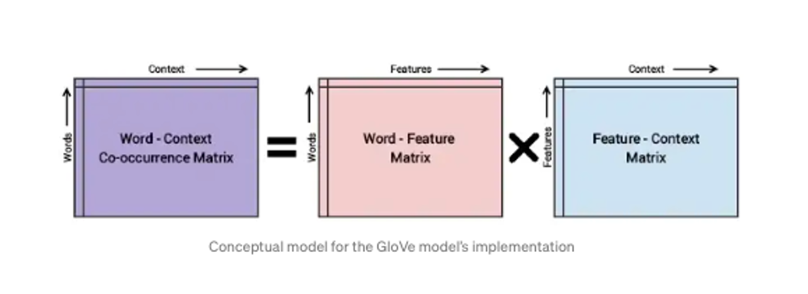
Figure 17: GloVe embeddings with statistical co-occurrence

From the 2014 GloVe paper itself, the algorithm is described as “…essentially a log-bilinear model with a weighted least-squares objective. The main intuition underlying the model is the simple observation that ratios of word-word co-occurrence probabilities have the potential for encoding some form of meaning.” Given that the GloVe algorithm is trained using global word to word co-occurrence matrices, it encodes more specificity regarding word association than Word2Vec because it uses word co-occurrence probabilities across an entire corpus to compute the embeddings, thereby encoding an extra layer of semantic information (meaning), allowing for greater performance and efficacy across a range of NLP tasks.

Having said that, it’s important to understand that both Word2Vec and GloVe construct a semantic space that leverages the position of a given word within the context of the textual corpus itself as the basis for its semantic spatial geometry so to speak, both relying on the distributional hypothesis but using different statistical techniques to encode the notion of ‘distribution’ as it were – Word2Vec being a more localized version, parametrized by its window size, and GloVe looking across the entire corpus at co-occurrence metrics. Furthermore both Word2Vec and GloVe word embeddings, despite their differences, nonetheless share the basic characteristics of modern word embeddings that make them powerful in an NLP context, namely that they 1) solve for the curse of dimensionality problem by minimizing the number of dimensions, or features, associated with a given NLP term, word or n-gram, and 2) can be pre-trained for use in a wide variety of applications without having to incur the cost of training for each application, the latter being a radical transformative step for the rate of NLP application development overall.

FastText
  - Joulin, A., Grave, E., Bojanowski, P., & Mikolov, T. (2016): "Bag of Tricks for Efficient Text Classification." FastText extends Word2Vec by incorporating character-level information into word embeddings. This enhances performance on morphologically rich languages and text classification PDF available here.
  - Bojanowski, P., Grave, E., Joulin, A., & Mikolov, T. (2017): "Enriching Word Vectors with Subword Information." Introduces FastText's subword information, allowing embeddings to capture the internal structure of words PDF available here.
  - FastText representations incorporate subword-level n-grams, improving performance in morphologically complex languages and providing more meaningful representations for rare words. The model is both fast and accurate for text classification and other NLP tasks.

Features:
- Fixed Representation: Each word has a single vector that does not change based on context. For instance, "bank" will have the same vector in "river bank" as in "money bank."
- Pre-trained: Models are often pre-trained on large corpora and can be used as static embeddings in various downstream tasks.
- Subword Information (FastText): Some embeddings can handle rare or unknown words using character-level n-grams.

Contextual Representations: Autoencoders, Attention Mechanisms & Transformers

One of the linguistic aspects, or levels of granularity, missing from the simple count vectorization as well as even the more advanced Word2Vec and GloVe word embedding techniques however is that despite their sophistication and ease of use, each word in these models has one and only one representation, a limitation given that one of the distinctive characteristics of language is that words in different contexts can have widely varying meanings, a property called polysemy in linguistics. To address this, more advanced, bi-directional Deep Learning techniques have been developed that allow both the local and global context of a given word (or term) to be taken into account when generating embeddings, thereby addressing some of the shortcomings of the Word2Vec and GloVe frameworks.

These models provide different vectors for words depending on their context.
- ELMo: Embeddings from Language Models generate word representations conditioned on the entire sentence, offering different vectors for the same word in different contexts. It uses bidirectional LSTM networks ​ (ar5iv)​.
- ELMo: Embeddings from Language Models (ELMo), introduced by Peters et al. in 2018, generates contextualized word embeddings by combining features from all layers of a bidirectional language model.
- BERT: Bidirectional Encoder Representations from Transformers is a transformer-based model that considers the full context of a word by looking both backward and forward in a sentence. BERT employs masked language modeling to predict missing words, resulting in deep, contextualized word representations. It is widely used for transfer learning​ (DATAVERSITY)​.
- BERT: Bidirectional Encoder Representations from Transformers (BERT), proposed by Devlin et al. in 2018, pre-trains a deep bidirectional Transformer model on large corpora to produce context-aware word embeddings. BERT has been highly influential in NLP tasks.

ELMo & Bidirectional LSTMs

The most popular of these types of approaches that have been recently developed are ELMo, short for Embeddings from Language Models (Peters et al 2018), and BERT, or Bidirectional Encoder Representations from Transformers (Devlin et al 2019). These word embedding techniques are more advanced than their predecessors in terms of encoding more information and as such have for the most part supplanted Word2Vec and GloVe in more advanced NLP applications - given the fact that they are also pre-trained on massive textual data sets, with no increase in overhead to the applications themselves and can in most cases, because it generates the same output data structure as their predecessors, i.e. word embeddings, can be basically swapped into existing applications with very little development cost.

ELMo was released by researchers from the Allen Institute for AI (now AllenNLP) and the University of Washington in 2018 (Peters et al 2018). ELMo uses character level encoding and a bi-directional LSTM (long short-term memory) a type of recurrent neural network (RNN) which produces both local and global context aware word embeddings. While forward language models compute the probability of a word given previous words and a backward language model does the opposite, ELMo leverages the bi-directional LSTM architecture to jointly maximize the likelihood of both the forward and backward words (characters actually in the case of ELMo), yielding better sense disambiguation support, addressing the polysemy issue where word meanings are contextualized and not fixed across the entire corpus (Wang et al 2020).

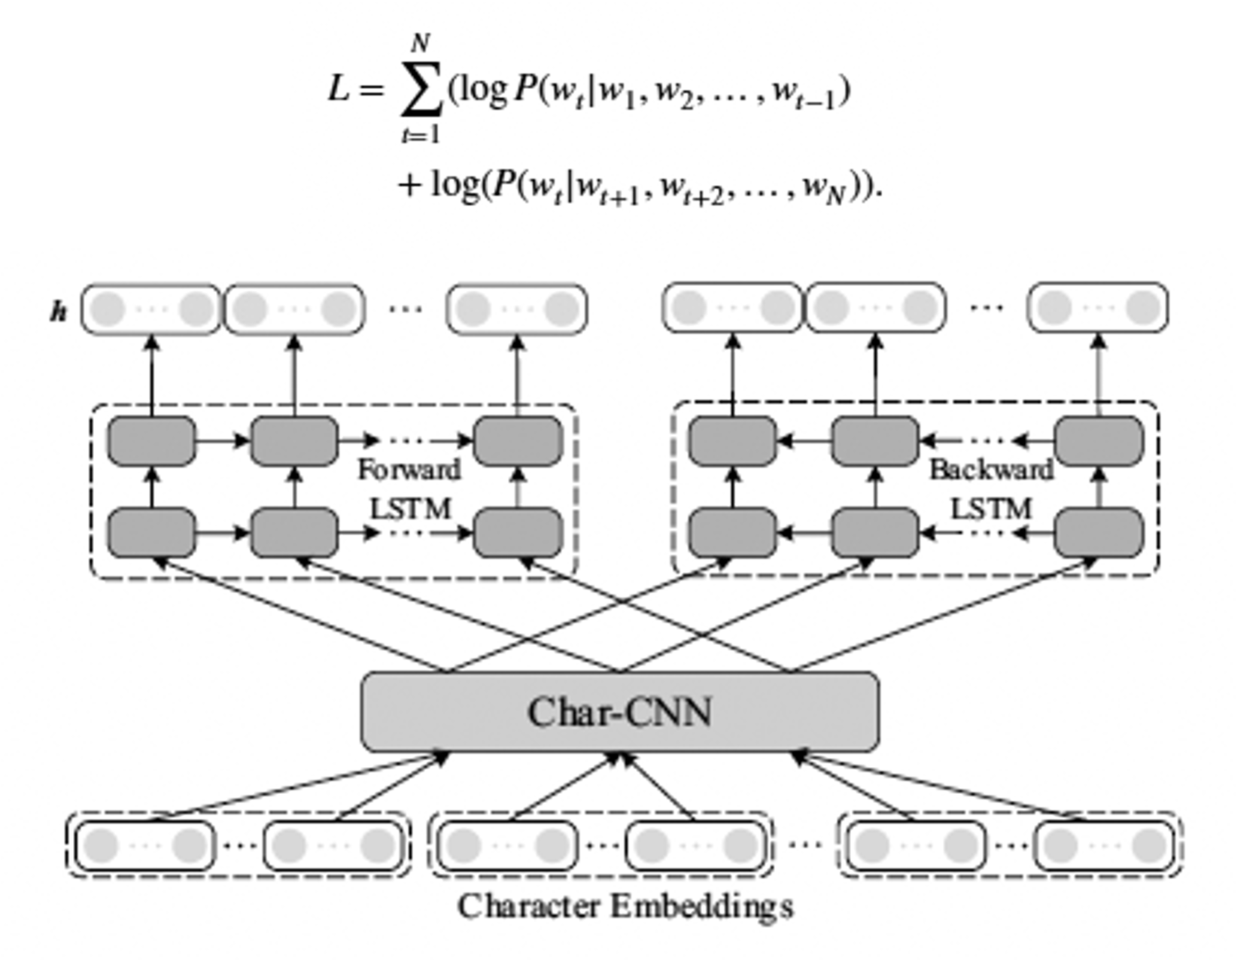
Figure 18: ELMo Objective Function Neural Network (bidirectional LSTM) Architecture

ELMo therefore represents a breakthrough in word embedding architecture given the additional semantic information it encodes as a result of its more sophisticated use of DL paradigms to effectively encode semantic information from two directions simultaneously, resulting in better performance versus the older word embedding techniques across a wide array of NLP problems such as question answering, named entity extraction, and sentiment analysis to name a few (Peters et al 2018, Wang et al 2020). ELMo also has the unique characteristic that, given that it uses character-based tokens rather than word or phrase based, it can also even recognize new words from text which the older models could not, solving what is known as the out of vocabulary problem (OOV).

Transformers & Attention Mechanisms

A further advancement in word embedding technology was made in 2018 when Google labs developed what is today arguably the most advanced word embedding language model / embedding framework based upon a new DL architectural framework called transformers (Vaswani et al 2017), a technology that had been developed a year prior that was designed and optimized specifically for language translation and that further extended the capabilities of prior DL constructed word embedding frameworks such as ELMo. Transformers are based upon encoder and decoder based neural network architecture that are specific designed to solve sequence-to-sequence based tasks, as are prevalent in NLP applications and design patterns like language translation for example, while supporting long range dependencies, the latter requirement representing one of the main breakthroughs of the technology as prior technologies, such as RNNs or CNNs, had limitations in terms of context size given the underlying neural network architecture.

As the 2017 paper title which introduced transformers indicates - Attention is All You Need – transformer architecture is predicated on the notion of self-attention, or simply the attention mechanism (Galassi et al 2021), which is the term used to describe the way in which transformers encode and decode sequences with no constraints on the size of the given context which is used to facilitate the transformation from inputs to outputs. In other words, with transformer encode-decode architecture, while the model focuses on a specific part of a given sequence, like a word or n-gram for example in an NLP context, the model still nonetheless has access to the entire textual input if necessary as context in order to facilitate the next prediction, or output, in the sequence, removing constraints on sequence context effectively.

These large language models are based on attention mechanisms. They can handle long-range dependencies in text, producing embeddings that represent complex linguistic features. GPT (Generative Pre-trained Transformer) focuses on text generation, while T5 (Text-to-Text Transfer Transformer) treats various NLP tasks as text transformation problems.

Structure: Each word or token is represented by a real-valued vector, but the representation is contextual, varying based on the surrounding tokens.
Dimensionality: Typically much larger than static embeddings, often 512 or 768 dimensions in models like BERT.
Training Methodology: Transformers use self-attention mechanisms that capture the relationships between all tokens in the input text simultaneously. This attention mechanism provides contextual embeddings that adapt according to the entire sentence, generating unique vectors for the same word depending on the context.

Purpose: Provide contextualized word representations and solve a wide range of NLP tasks, from text classification to translation.

Examples: BERT, GPT-3, T5.

- GPT (Generative Pre-trained Transformer): Radford et al. in 2018 proposed GPT, a transformer-based model pre-trained using a generative language modeling objective.
- XLNet: Yang et al. in 2019 introduced XLNet, which combines the best of autoregressive and autoencoding language modeling objectives, achieving state-of-the-art results on multiple benchmarks.
- T5: Text-to-Text Transfer Transformer (T5), proposed by Raffel et al. in 2019, frames all NLP tasks as text-to-text tasks and achieves impressive results by pre-training on a diverse range of tasks.

Features:
- Contextual Representation: Each word is represented differently based on its surrounding context. For instance, "bank" will have different vectors in "river bank" and "money bank."
- Attention Mechanism: Utilizes a self-attention mechanism to capture long-range dependencies between words in a sentence.
- Bidirectional vs. Unidirectional: BERT reads text in both directions (left to right and right to left), while GPT only reads text from left to right.
- Pre-training & Fine-tuning: Transformers are first pre-trained on large datasets to capture general linguistic patterns and then fine-tuned on specific tasks.

Both word embeddings and transformer models use vectors of real numbers to represent each word or token. However, the way these vectors are constructed and the underlying principles differ. While word embeddings are simpler and provide static representations, Transformer models generate dynamic, contextual representations using powerful attention mechanisms, allowing them to excel in understanding complex linguistic nuances​ (DATAVERSITY)​.

While both word embeddings and transformer models represent words as vectors of real numbers, the former provides static, context-independent vectors, while the latter generates context-specific representations.

BERT

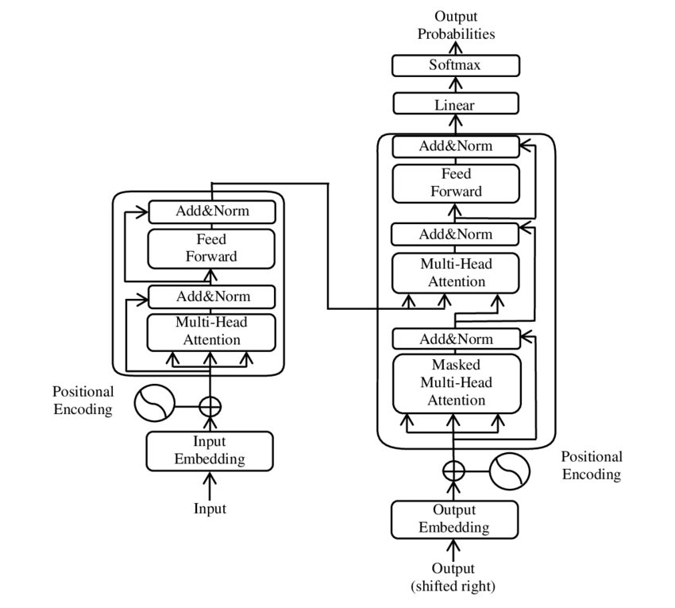
Figure 19: Transformer architecture

BERT was developed at Google and was released in 2019 in a paper entitled BERT: Pre-training of Deep Bidirectional Transformers for Language Understanding, and, as the title refers to, leverages a transformer-based architecture, and the attention mechanism to achieve state of the art performance on a wide range of NLP tasks such as chatbots, question and answering capabilities, natural language inference capability, classification and named entity recognition tasks and more, leveraging stronger contextualized textual representations than any of its predecessors. BERT leverages this transformer based attention mechanism which emphasizes or enhances some parts of the text while de-emphasizing others using weighting techniques which are common in deep learning applications and also has the unique property of bidirectionality, which means that it can process, i.e. read text, in both directions (front to back and back to front or right to left and left to right as the case may be) at the same time, greatly increasing training performance compute times and resource requirements.

The model itself uses two novel training techniques together to develop a robust set of embeddings associated with words that goes well beyond simple text based vectorization techniques that we have discussed prior – the first is masked language model (MLM), which is designed to mask words and have the model predict them randomly throughout the sequence, and the other is next sequence prediction (NSP) which predicts whether or not a given sentence A will follow a given sentence B, the two methods being optimized for jointly working in parallel to provide a sort of multi-dimensional semantic view of the text being processed. (Wang et al 2020). It also is designed to come in pre-trained formats, BERT_large which comes with over 345 million parameters or BERT_base which has just over 110 million, both of which are designed to be integrated into NLP applications as is (pre-trained) and yet still allow for further customization of the embeddings to support a given task at hand.

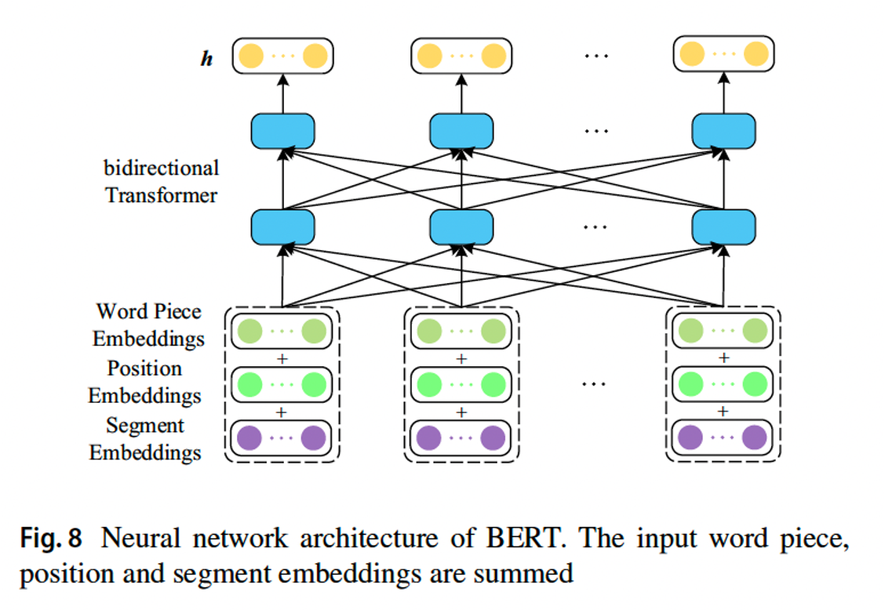
Figure 20: Bidirectional Encoder Representation from Transformers Architecture (BERT)

So with both ELMo and BERT computed word (token) embeddings then, each embedding contains information not only about the specific word itself, but also the sentence within which it is found as well as context related to the corpus (language) as a whole. As such, with these advanced forms of word embeddings, we can solve the problem of polysemy as well as provide more context-based information for a given word which is very useful for semantic analysis and has a wide variety of applications in NLP. These methods of word embedding creation take full advantage of modern, DL architectures and techniques to encode both local as well as global contexts for words. It is in fact these more modern DL architectures which have facilitated the development of these more effective and performant word embedding architectures, paving the way for the success of modern language models such as BERT (designed for language modeling and next word or sentence prediction by Google and used in their search engine) as well as GPT, another deep learning, pre-trained language model used for text and language prediction (predictive text).

Alternative Forms of Representation

Sentence and Document Embeddings
- Doc2Vec: An extension of Word2Vec proposed by Le and Mikolov in 2014, Doc2Vec learns fixed-size representations for variable-length pieces of text, such as sentences or documents.
- Skip-Thought Vectors: Introduced by Kiros et al. in 2015, Skip-Thought Vectors learn to generate context-aware sentence embeddings by predicting the surrounding sentences.
- InferSent: Conneau et al. in 2017 proposed InferSent, which learns universal sentence embeddings using supervised learning on various NLP tasks.

Quantum Language Models

Quantum models of language representation represent a cutting-edge approach that seeks to leverage principles from quantum computing and quantum mechanics to enhance natural language processing (NLP) tasks. While still in its early stages, this emerging field holds promise for addressing certain challenges in traditional NLP models, such as handling large-scale semantic spaces and capturing complex linguistic phenomena. Here's a detailed summary, citing key developments in research and their relevant citations:

Key Idea: Quantum NLP aims to utilize quantum computing principles to encode and process language representations more efficiently and effectively than classical methods.
Reference: Quantum NLP was first introduced as a concept by Croucher in his paper "The physics of language" (2005), which proposed applying quantum methods to model language semantics.

Key Idea: Rather than directly utilizing quantum computing hardware, quantum-inspired models apply quantum principles to classical computing frameworks, such as neural networks, to improve language representation.
Development: Huang et al. proposed the Quantum-Inspired Language Model (QILM) in their paper "Quantum-inspired language model" (2020), which employs quantum circuits to capture long-range dependencies in language data more efficiently.

Key Idea: Quantum word embeddings seek to represent words in a continuous vector space using quantum-inspired methods, potentially capturing richer semantic relationships compared to classical word embeddings.
Development: Wiebe et al. introduced the Quantum Embedding of Semantic Space (QUESS) model in their paper "Quantum Embedding of Semantic Space: A Quantum-inspired Approach to Representation Learning" (2016), demonstrating improved performance in semantic similarity tasks compared to classical word embeddings.

Key Idea: Quantum language models extend traditional language modeling techniques by incorporating quantum principles to represent and generate coherent sequences of words.
Development: Benedetti et al. proposed the Quantum Natural Language Model (QNLM) in their paper "Parameterized Quantum Circuits as Machine Learning Models" (2019), which uses quantum circuits to generate text sequences probabilistically, showing potential for quantum-enhanced language modeling tasks.

Key Idea: Inspired by the success of the Transformer architecture in NLP, quantum transformers explore the application of quantum computing principles to enhance the performance of transformer-based models.
Development: Yuan et al. introduced the Quantum Transformer (QT) model in their paper "Quantum Transformer: A Novel Architecture for Quantum Language Modeling" (2021), which combines classical transformers with quantum gates to improve language modeling capabilities.

Key Idea: Hybrid models leverage both quantum and classical computing resources to address specific challenges in language representation and processing.
Development: Liu et al. proposed the Quantum Natural Language Understanding (QNLU) framework in their paper "Hybrid Quantum-Classical Natural Language Understanding" (2021), which combines classical NLP methods with quantum algorithms to enhance language understanding tasks.

These developments illustrate the ongoing exploration of quantum principles in language representation and processing. While still in its nascent stages, quantum NLP holds potential for advancing various NLP tasks by harnessing the power of quantum computing paradigms.

Key Papers and References

- Bag of Words & TF-IDF:
  - Salton, G. & McGill, M. J. (1986): Introduction to Modern Information Retrieval. This book introduces the vector space model and provides details on TF-IDF scoring.
- Word Embeddings:
  - Mikolov, T., Chen, K., Corrado, G., & Dean, J. (2013): "Efficient Estimation of Word Representations in Vector Space." This paper introduces Word2Vec's CBOW and Skip-gram models PDF available here.
  - Pennington, J., Socher, R., & Manning, C. D. (2014): "GloVe: Global Vectors for Word Representation." Describes the GloVe model, combining global and local statistics for better word representations PDF available here.
- Contextual Representations:
  - Peters, M. E. et al. (2018): "Deep Contextualized Word Representations." Presents ELMo and its context-sensitive embeddings, allowing different vectors for the same word based on context PDF available here.
  - Devlin, J., Chang, M. W., Lee, K., & Toutanova, K. (2018): "BERT: Pre-training of Deep Bidirectional Transformers for Language Understanding." Introduces BERT, a Transformer model for context-based language understanding PDF available here.
- Vector Space Models:
  - Salton, G. et al. (1975): "A Vector Space Model for Automatic Indexing." Describes vector space models in document indexing PDF available here.
- Transformer Models:
  - Vaswani, A. et al. (2017): "Attention Is All You Need." Introduces the Transformer architecture underpinning models like BERT and GPT PDF available here.

- Al-Twairesh, N. (2021). The evolution of language models applied to emotion analysis of arabic tweets. Information, 12(2), 84. https://doi.org/10.3390/info12020084
- Buey, M., Bobed, C., Gracia, J., & Mena, E. (2020). Semantic relatedness for keyword disambiguation: exploiting different embeddings.. https://doi.org/10.48550/arxiv.2002.11023
- Devlin, J., Chang, M., Lee, K., & Toutanova, K. (2019). Untitled.. https://doi.org/10.18653/v1/n19-1423
- Howard, J. and Ruder, S. (2018). Universal language model fine-tuning for text classification.. https://doi.org/10.18653/v1/p18-1031
- Liu, X., He, P., Chen, W., & Gao, J. (2019). Multi-task deep neural networks for natural language understanding.. https://doi.org/10.18653/v1/p19-1441
- Ofer, D., Brandes, N., & Linial, M. (2021). The language of proteins: nlp, machine learning &amp; protein sequences. Computational and Structural Biotechnology Journal, 19, 1750-1758. https://doi.org/10.1016/j.csbj.2021.03.022
- Peters, M., Neumann, M., Iyyer, M., Gardner, M., Clark, C., Lee, K., … & Zettlemoyer, L. (2018). Deep contextualized word representations.. https://doi.org/10.18653/v1/n18-1202
- Xiong, Y., Chen, S., Chen, Q., Yan, J., & Tang, B. (2020). Using character-level and entity-level representations to enhance bidirectional encoder representation from transformers-based clinical semantic textual similarity model: clinicalsts modeling study. Jmir Medical Informatics, 8(12), e23357. https://doi.org/10.2196/23357

Latest Developments and Research

Recent advancements in language representation methods for Natural Language Processing (NLP) have been significant, with models like BERT (Bidirectional Encoder Representations from Transformers) leading the way (Devlin et al., 2019). Unlike previous models, BERT is designed to pretrain deep bidirectional representations from unlabeled text by considering both left and right context in all layers, resulting in enhanced performance across various NLP tasks.

In addition to BERT, other models such as ELMo, GPT, and Universal Language Model Fine-tuning (ULMFiT) have also played a crucial role in improving language representation in NLP (Liu et al., 2019; Howard & Ruder, 2018). These models utilize deep contextual representations and transfer learning techniques to pretrain neural text representations on large datasets, producing versatile and effective representations that can be fine-tuned for specific tasks.

The use of word embeddings, contextualized embeddings, deep learning, and neural language models has become prevalent in NLP research (Ofer et al., 2021). These techniques allow for the conversion of textual information into numerical vectors that capture semantic relationships between words and phrases, enabling a more nuanced understanding of language data.

In summary, methods of text representation have evolved from simple frequency-based models to complex neural architectures capable of understanding subtle semantic nuances, enabling a wide range of modern NLP applications like machine translation, summarization, and question answering.

Recent studies have explored the application of NLP methods in various domains such as protein sequence analysis, emotion analysis of social media content, and clinical text processing (Ofer et al., 2021; Al-Twairesh, 2021; Xiong et al., 2020). These studies demonstrate the adaptability of language representation models in capturing domain-specific information and deriving meaningful insights from text data.

Furthermore, advancements in representation learning models, including word embeddings and language models, have led to improved performance in a range of NLP tasks such as question answering, textual entailment, sentiment analysis, and semantic similarity (Peters et al., 2018; Buey et al., 2020; Xiong et al., 2020). These models leverage dense representations of words and sentences to capture intricate linguistic features and semantic nuances present in text data.

In conclusion, the latest research in language representation methods for NLP emphasizes the importance of utilizing deep learning techniques, pretraining strategies, and contextual embeddings to enhance the efficiency and effectiveness of natural language understanding and processing tasks. Continuous refinement and innovation in language representation models are expanding the boundaries of NLP capabilities and creating new opportunities for applications across diverse fields.

These are some of the key approaches in representation learning for NLP. While these models have significantly advanced the state-of-the-art in various NLP tasks, the field continues to evolve rapidly with new architectures and techniques emerging regularly.

Use of Embeddings in NLP Solves

The construction methods for different types of text embeddings (TF-IDF, Count Vectorization, Word2Vec, GloVe) differ significantly in terms of the underlying principles. Let’s break it down by analogy, comparing them in a numeric or algebraic sense.

Frequency Based Construction

TF-IDF or Count Vectorization (Algebraic Construction) or Numeric (explicit frequency-based)

These are explicit vector representations of words based on the frequency or co-occurrence of words in the corpus. The process relies on counting word occurrences and manipulating those counts through algebraic transformations.

  - Count Vectorizer: The vector for each document is based on the raw counts of words.
  - TF-IDF Vectorizer: The vector for each document is a transformation of raw word counts, adjusted by the inverse document frequency (IDF), which diminishes the weight of common words.

This is akin to constructing a vector by measuring the direct frequency of each word (or feature) in a document. Each dimension of the vector corresponds to a specific word in the vocabulary. Example: A document with the words “apple,” “banana,” and “fruit” might be represented as [2, 1, 3] if "apple" appears twice, "banana" once, and "fruit" three times.

Co-Occurrence Based Methods

Word2Vec or GloVe (Geometric Construction):

Geometric / Numeric (latent vector space)

Word2Vec and GloVe are implicit vector representations. Instead of relying directly on word counts, they use more sophisticated methods to learn latent representations of words based on their contexts (co-occurrences) in large corpora.

Word2Vec:
- Uses a neural network to predict either the target word given its context (CBOW) or the context given the target word (Skip-gram).
- During training, words that appear in similar contexts end up being represented by vectors that are geometrically close to each other in a high-dimensional space.
- Geometric Analogy: This is akin to finding the coordinates of each word in a latent space where distances between vectors reflect their semantic similarity.
- Example: The word “apple” might have a vector like [0.25, -0.12, 0.75, ...], learned from context-based training, with dimensions representing abstract semantic relationships.

GloVe:
- Uses global word co-occurrence statistics to derive word vectors, where words that frequently co-occur in the same context have similar vectors.
- The optimization process minimizes the difference between the dot product of two word vectors and the logarithm of their co-occurrence count, leading to a word embedding.
- Geometric Analogy: GloVe tries to position words in a vector space such that their co-occurrence patterns can be expressed by linear relationships.
- Example: The word "king" might be placed in a high-dimensional space where the relationship "king - man + woman ≈ queen" holds, implying a more geometric interpretation.

TF-IDF / Count Vectorization is explicit, algebraic construction based on word frequencies. Each vector dimension represents a distinct, interpretable feature (e.g., the presence or absence of a word), representing a direct frequency-based transformation of the raw data. Word2Vec and GloVe on the other hand, are geometric based, implicit constructions of word vectors in a continuous latent space. Vectors are learned through training on large corpora to capture semantic and syntactic relationships. These are dense, distributed representations where each dimension captures abstract relationships rather than direct counts.

In essence, while TF-IDF and Count Vectorization build vectors through explicit algebraic transformations of text data, Word2Vec and GloVe use machine learning to geometrically place words into a latent vector space based on their usage patterns in large corpora. The former gives clear, interpretable vectors (e.g., word counts), while the latter produces more abstract, dense representations.

FastText is similar to Word2Vec in that it is a co-occurrence-based model that represents words in a Euclidean space, but it has a key distinction: subword information.

How FastText Differs from Word2Vec:
- Subword Information:
  - Unlike Word2Vec, which treats each word as a single atomic unit, FastText breaks down words into character n-grams (subword units). For example, the word "apple" might be broken down into character n-grams like "app," "ppl," and "ple."
  - Each word is represented not only by its word-level embedding but also by the embeddings of its subwords (n-grams). This enables FastText to generate embeddings for out-of-vocabulary words by composing them from the embeddings of their subwords.
  - Analogy: If Word2Vec is constructing a word vector from the entire word (as a whole point in space), FastText constructs word vectors from both the whole word and its parts (n-grams), distributing its construction across subword components.
- Contextual Learning:
  - FastText, like Word2Vec, uses a Skip-gram or CBOW model, where the learning task involves predicting a word from its context (or vice versa).
  - The vectors for words that appear in similar contexts end up close to each other in the embedding space.
  - In this sense, FastText is also co-occurrence-based, leveraging the context of words in a large corpus to learn meaningful embeddings.

Just like Word2Vec, FastText operates in a continuous Euclidean space (or more generally, a vector space) where words with similar meanings have vectors that are close together and relationships between words can be modeled as linear transformations (e.g., "king - man + woman ≈ queen"). Since FastText breaks words into subword units (n-grams), this means that similar words (e.g., "running" and "runner") will have more similar vectors than they would in Word2Vec, due to shared subword components ("run").

FastText also constructs vectors geometrically, learning word and subword representations from their co-occurrence patterns in a latent space. During training however, FastText learns embeddings not just for entire words but also for their subword n-grams. When creating the final vector for a word, FastText aggregates the word's subword embeddings (and its own embedding if available) into a single vector, resulting in embeddings that can handle morphologically rich languages better than Word2Vec, which cannot break words into smaller units.

For the word "apple" for example, word-level embedding: "apple" might have a word-level embedding, similar to Word2Vec, whereas with subword-level embeddings, the word might also be broken into character n-grams like "app," "ppl," and "ple," each of which has its own learned embedding. The final vector for "apple" is the sum or average of its word-level embedding and the embeddings of its subword n-grams. FastText also computes and operates in Euclidean space, where words and subwords are represented as vectors. FastText also, like its word based counterparts word2vec and glove, primarily uses co-occurrence statistics to generate its word embeddings (vectors) – i.e. words (and subwords) that frequently appear in similar contexts will have vectors close together in this space.

This geometric model allows FastText to capture not just word-level relationships, but also similarities across words with shared subwords, such as:
- Morphological variations: "run," "running," "runner" will have closer embeddings because of shared subwords.
- Misspellings or unseen words: FastText can produce reasonable embeddings for out-of-vocabulary words based on their subwords.

FastText is indeed a co-occurrence-based model in Euclidean space, similar to Word2Vec and GloVe, however, its key innovation is the use of subword information. This allows FastText to generate more accurate embeddings for rare words, morphologically complex words, and even unseen words by leveraging character-level n-grams. In the Euclidean space, FastText ensures that both word-level and subword-level co-occurrence patterns are captured, making it robust for handling languages with rich morphology or large vocabularies.

Contextualized Embeddings

BERT (Bidirectional Encoder Representations from Transformers) and RoBERTa (Robustly Optimized BERT Pretraining Approach) have more complex embedding construction methods compared to models like Word2Vec or FastText, as they are based on deep contextualized embeddings using the Transformer architecture. Their construction methods can be described in algebraic, probabilistic, and geometric terms, but they diverge from simpler word embedding models because they generate context-dependent representations for each token.

Both BERT and RoBERTa use Transformer models that employ self-attention mechanisms to generate token embeddings. The main difference between these models and earlier approaches (Word2Vec, GloVe, FastText) is that the embeddings generated by BERT and RoBERTa are:
- Contextual: The same word can have different embeddings depending on its context.
- Subword-based: They break words into subwords (wordpieces), similar to FastText, but the focus is on dynamic tokenization based on context.
- Deep embeddings: Generated from multiple layers of Transformer networks.

BERT and RoBERTa rely on the Transformer's self-attention mechanism, which learns relationships between every word (or subword) in a sentence. For each word in a sentence, the model computes attention scores for all other words, forming a probabilistic representation of how much attention each word should pay to every other word in the sentence. These attention scores are used to weight the embeddings from previous layers, allowing the model to encode context dynamically for each word. Each word is re-positioned in a high-dimensional space based on how it relates to other words in the sentence. This is done through weighted linear combinations of embeddings based on the attention scores, causing the embeddings to shift depending on the context.

Unlike Word2Vec or GloVe, which assign a fixed vector to each word, BERT and RoBERTa generate dynamic embeddings based on the sentence. For example, the word "bank" will have different embeddings in "river bank" vs. "financial bank." Each layer of the Transformer network modifies the embedding of a word based on algebraic transformations (matrices of weights, biases, and nonlinear activations) and the attention mechanism. The final embedding of a word is the result of multiple layers of matrix transformations, making it a deep representation of the word and its surrounding context.

BERT and RoBERTa are pretrained on massive amounts of text data using masked language modeling (MLM) and (for BERT) next sentence prediction (NSP). During pretraining, part of the sentence is hidden (masked), and the model is trained to predict the missing word. MLM introduces probabilistic predictions into the model’s learning process. The embeddings that result from MLM are optimized for downstream tasks, such as classification, named entity recognition, or question answering. The pretrained model is further fine-tuned on specific tasks, allowing BERT or RoBERTa to adjust its embeddings based on task-specific data.

BERT considers the entire context of a word from both directions (left-to-right and right-to-left) using the self-attention mechanism. This means that the embedding for a word in BERT is influenced by both the preceding and succeeding words in a sentence, making the embeddings contextual and bidirectional. RoBERTa builds on BERT but removes the next sentence prediction (NSP) task and introduces changes to pretraining hyperparameters, such as training with larger batch sizes and more data. This leads to better generalization performance. RoBERTa uses dynamic masking during pretraining, meaning the mask positions are selected randomly each time a sequence is fed into the model. This leads to more robust embeddings.

With BERT/RoBERTa, each token's embedding is influenced by the entire sentence using a probabilistic attention mechanism. Words or subwords in the sentence contribute to the final embedding based on the attention weights learned during training. Embeddings are constructed by layering algebraic transformations (matrices of weights, biases, non-linear activations) across multiple layers (12 layers for BERT-base, 24 layers for BERT-large/RoBERTa-large), and embeddings are context-sensitive, meaning the same word has different embeddings depending on its surrounding words. Words are broken into subword units (WordPiece tokens), and their embeddings are learned and combined using attention mechanisms. This makes BERT and RoBERTa effective at handling out-of-vocabulary words and morphologically complex languages.

In the embedding space, BERT and RoBERTa learn to position words in a way that encodes both syntactic and semantic relationships, but these relationships are deeply tied to the specific context. In BERT/RoBERTa's embedding space, the distance between words is not just based on their isolated meaning but on how they interact with other words in a given sentence or passage. Thus, the same word can have multiple geometric positions depending on the sentence in which it appears. BERT and RoBERTa embeddings are contextual, probabilistic, and dynamic, differing from static embeddings like Word2Vec or GloVe, where each word has a single fixed vector. Instead, BERT and RoBERTa dynamically adjust word embeddings based on the context within the sentence. Just like Word2Vec or GloVe however, BERT and RoBERTa operate in Euclidean space, but with a much deeper and more sophisticated construction process that reflects the complex relationships between words in different contexts. In essence, BERT and RoBERTa construct embeddings through a combination of probabilistic attention mechanisms and deep algebraic transformations across multiple layers, resulting in rich, context-sensitive word vectors in Euclidean space.

LLaMA (Large Language Model Meta AI) is another transformer-based model similar to GPT, BERT, and RoBERTa, but it is designed specifically for efficiency and scalability. The construction method of LLaMA embeddings shares many similarities with models like GPT, BERT, and RoBERTa, but LLaMA has specific optimizations in terms of efficiency and scaling for large datasets and long contexts.

LLaMA is an autoregressive transformer model, which means it generates embeddings (and predictions) by looking at past tokens in a sequence (unidirectional context). It's similar to GPT models but with several architectural and training adjustments that make it more efficient and capable of handling large contexts. LLaMA constructs embeddings for each word (or token) based on the previous tokens in the sequence. It reads the input text from left to right and predicts the next token based on the tokens that came before it. At each step, the model applies a series of algebraic transformations (matrix multiplications, biases, and non-linear activations) to generate embeddings for each token in the sequence. Each token embedding is influenced by the attention mechanism that assigns probabilities to how much the model should focus on different preceding tokens.

The self-attention mechanism is at the core of LLaMA’s architecture, just like in other transformer models. This mechanism allows each token to focus on (or "attend to") other tokens in the sequence based on their relevance. For each token, LLaMA computes attention scores that determine how much weight to give to each preceding token. These attention scores are derived from the dot products of token embeddings and are normalized via softmax to produce probabilities. Each token is placed in a high-dimensional vector space where its position is adjusted based on its relationship with other tokens in the context. Tokens that share similar contexts will have embeddings that are closer to each other in this space.

LLaMA consists of multiple layers of transformers, each layer performing a sequence of algebraic operations, including matrix multiplications, bias additions, and non-linear activation functions (typically GELU or ReLU). The token embeddings are updated layer by layer, incorporating more contextual information at each step. The embeddings are built through repeated transformations across these layers, making them more refined as they pass through the network. Like other transformer-based models, LLaMA operates in a high-dimensional Euclidean space, where each token (or word) is represented as a vector. In this space, the geometry of the embedding reflects the model's learned relationships between tokens. Similar words or phrases will tend to have similar vectors, and relationships between words can often be modeled as geometric transformations (e.g., vector arithmetic). The embedding of each word changes depending on the words around it, as the attention mechanism continually adjusts its representation based on its dynamic interaction with the rest of the sequence.

LLaMA is pretrained using causal language modeling, where the model is trained to predict the next token based on the previous ones in the sequence. This training process generates highly contextualized embeddings that capture the meaning of a word in its specific context. LLaMA focuses on training efficiency, using smaller models that can achieve comparable or better performance to much larger models by optimizing the architecture, training procedure, and data utilization. LLaMA uses a relatively small tokenizer vocabulary, which reduces computational cost during training and inference. This ensures the embedding construction is efficient even for large datasets. LLaMA can scale up efficiently, meaning it can handle very large datasets and long sequences while still maintaining high performance. This makes it ideal for tasks that require processing a lot of text, like long documents or conversations.

LLaMA is unidirectional/autoregressive, meaning it generates embeddings based only on the tokens that have come before a given word in the sequence. In contrast, BERT and RoBERTa are bidirectional, meaning they take both left and right contexts into account when generating embeddings. This makes LLaMA more suitable for generative tasks, while BERT/RoBERTa are better suited for tasks requiring full-sentence understanding. LLaMA uses causal language modeling like GPT, whereas BERT uses masked language modeling, where words are masked and the model is trained to predict the missing words using both left and right context.

LLaMA relies heavily on attention, where each token focuses on other tokens based on learned attention weights, producing contextualized embeddings. This mechanism is similar to that of BERT, GPT, and RoBERTa but applied autoregressively. Embeddings are constructed via multiple layers of algebraic transformations (linear projections, biases, and activations). These deep transformations allow LLaMA to build rich, context-sensitive representations of tokens. Like other transformer models, LLaMA embeds tokens in a high-dimensional Euclidean space, where the geometry reflects the learned relationships between tokens. The space captures both syntactic and semantic information based on the token's role in the context. One of LLaMA’s key strengths is its efficiency and scalability, enabling it to handle large amounts of data with fewer computational resources compared to larger models like GPT-3.

LLaMA is a contextual, autoregressive model that constructs embeddings in a Euclidean space using the same fundamental building blocks as other transformer models: attention, algebraic transformations, and deep neural networks. However, its focus on scalability and efficiency makes it highly competitive, offering powerful language modeling capabilities with fewer computational resources.

Large Language Models

LLM definition

LLM families and their evolution

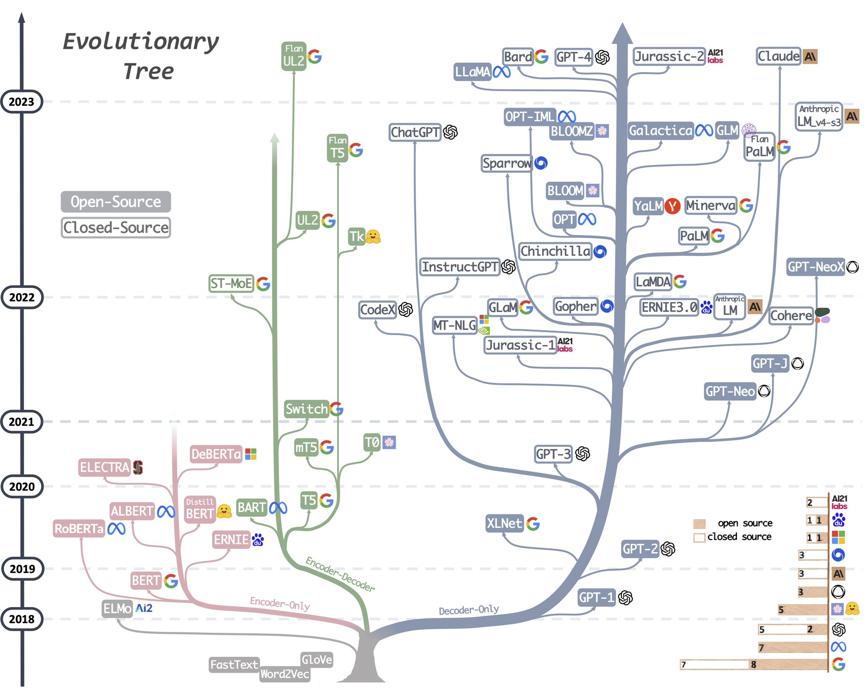
Figure 21: Language Model Evolutionary Tree (Yang, et al., 2023)

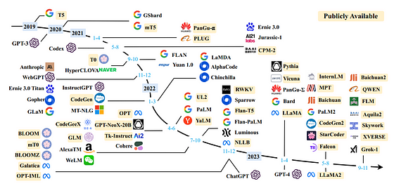
Figure 22: LLM Families and their Development (Zhao, et al., 2023)

Representative LLLMs, focusing on language models – versus multi-modal capabilities from GPT-4, Gemini, etc

Deeper analysis and selection criteria

LLaMA (Meta)

ChatGPT (OpenAI)

PaLM (Google)

Claude (Anthropic)

Summary

Bibliography
Albrecht, J., Ramachandran, S. & Winkler, C., 2020. Blueprints for Text Analytics Using Python. s.l.:O'Reilly Media, Inc..
Bender, E. M. & Koller, A., 2020. Climbing towards NLU: On Meaning, Form, and Understanding in the Age of Data. s.l., Association for Computational Linguistics, pp. 5185-5198.
Chang, T. A. & Bergen, B. K., 2024. Language Model Behavior: A Comprehensive Survey. Computational Linguistics, 03, 50(1), pp. 293-350. https://doi.org/10.1162/coli_a_00492.
Chomsky, N., 1956. Three models for the description of language. IRE Transactions on Information Theory, September, 2(3), pp. 113-124. https://doi.org/10.1109/TIT.1956.1056813.
Chomsky, N., 1957. Syntactic Structures. Berlin, Boston: De Gruyter Mouton.
Chomsky, N., 1965. Aspects of the Theory of Syntax. Cambridge(MA): MIT Press.
Deerwester, S. et al., 1990. Indexing by latent semantic analysis. Journal of the American Society for Information Science, 41(6), pp. 391-407. https://doi.org/10.1002/(SICI)1097-4571(199009)41:6<391::AID-ASI1>3.0.CO;2-9.
Devlin, J., Chang, M.-W., Lee, K. & Toutanova, K., 2019. BERT: Pre-training of Deep Bidirectional Transformers for Language Understanding. Minneapolis, Minnesota, Association for Computational Linguistics, pp. 4171-4186. https://doi.org/10.48550/arXiv.1810.04805.
Farrando, J., Sarti, G., Bisazza, A. & Costa-jussà, M. R., 2024. A Primer on the Inner Workings of Transformer-based Language Models. Preprint, p. 55..
Fitch, W. T., 2010. The Evolution of Language. s.l.:Cambridge University Press.
Hutchins, J. W., 2004. The Georgetown-IBM experiment demonstrated in January 1954. Berlin, Heidelberg, Springer Berlin Heidelberg, pp. 102-114. https://doi.org/10.1007/978-3-540-30194-3_12.
Jurafsky, D. & Martin, J. H., 2024. Speech and Language Processing: An Introduction to Natural Language Processing, Computational Linguistics, and Speech Recognition. s.l.:Prentice Hall, Pearson Education International.
Khurana, D., Koli, A., Khatter, K. & Singh, S., 2022. Natural language processing: state of the art, current trends and challenges. Multimedia Tools and Applications, July, 82(3), pp. 3713-3744. http://dx.doi.org/10.1007/s11042-022-13428-4.
Mikolov, T., Chen, K., Corrado, G. & Dean, J., 2013. Efficient Estimation of Word Representations in Vector Space. s.l., arXiv, p. https://doi.org/10.48550/arXiv.1301.3781.
Minaee, S. et al., 2024. Large Language Models: A Survey. ArXiv, Volume abs/2402.06196.
Mitchell, M. & Krakauer, D. C., 2023. The debate over understanding in AI’s large language models. Proceedings of the National Academy of Sciences, March, 120(13), p. http://dx.doi.org/10.1073/pnas.2215907120.
Patel, F., 2019. Singular Value Decomposition(SVD) : A simple, comprehensive and practical introduction. [Online]
Available at: https://medium.com/@faizanmukardam/singular-value-decomposition-svd-a-simple-comprehensive-and-practical-introduction-6add3dc6793d
[Accessed June 2024].
Pennington, J., Socher, R. & Manning, C. D., 2014. GloVe: Global Vectors for Word Representation. Doha, Qatar, Association for Computational Linguistics, pp. 1532-1543. 10.3115/v1/D14-1162.
Peters, M. E. et al., 2018. Deep contextualized word representations. New Orleans, Louisiana, Association for Computational Linguistics, pp. 2227-2237. https://doi.org/10.48550/arXiv.1802.05365.
Pierce, J. & Carroll, J. B., 1966. Language and Machines - Computers in Translation and Linguistics, Washington, DC: s.n.
Raiaan, M. Z. K. et al., 2024. A Review on Large Language Models: Architectures, Applications, Taxonomies, Open Issues and Challenges. IEEE Access, Volume 12, pp. 26839-26874. http://dx.doi.org/10.1109/ACCESS.2024.3365742.
Salton, G., 1971. The SMART Retrieval System-Expermients in Automatic Document Processing. s.l.:Prentic-Hall, Inc..
Schank, R. C., Goldman, N., Riager, C. J. & Rissbeck, C., 1973. Margie memory, analysis, response generation, and inference on English. San Francisco, CA, Morgan Kaufmann Publishers Inc., pp. 255-261.
Shardlow, M. & Przybyła, P., 2023. Deanthropomorphising NLP: Can a Language Model Be Conscious?. arXiv, p. https://doi.org/10.48550/arXiv.2211.11483.
Sparck Jones, K., 1972. A STATISTICAL INTERPRETATION OF TERM SPECIFICITY AND ITS APPLICATION IN RETRIEVAL. Journal of Documentation, 01 January, 28(1), pp. 11-21. https://doi.org/10.1108/eb026526.
Turing, A., 1950. Computing Machinery adn Intelligence. Mind, October, 59(236), pp. 433-460. https://doi.org/10.1093/mind/LIX.236.433.
Turing, A. M., 1950. Computing Machinery and Intelligence. Mind, October, 49(236), pp. 433-460. https://doi.org/10.1093/mind/LIX.236.433.
Vaswani, A. et al., 2017. Attention is All You Need. Long Beach, CA, Curran Associates Inc., p. https://doi.org/10.48550/arXiv.1706.03762.
Wan, Z. et al., 2024. Efficient Large Language Models: A Survey. ArXiv, Volume abs/2312.03863, p. https://doi.org/10.48550/arXiv.2312.03863.
Winograd, T., 1972. Procedures As A Representation For Data In A Computer Program For Understanding Natural Language. Cognitive Psychology, 3(1).
Worth, P., 2023. Word Embeddings and Semantic Spaces in Natural Language Processing. International Journal of Intelligence Science, 13(1), pp. 1-21. https://doi.org/10.4236/ijis.2023.131001.
Yang, J. et al., 2023. Harnessing the Power of LLMs in Practice: A Survey on ChatGPT and Beyond. p. https://doi.org/10.48550/arXiv.2304.13712.
Zhao, W. X. et al., 2023. A Survey of Large Language Models. ArXiv, Volume abs/2303.18233, pp. 1-124. 10.48550/arXiv.2303.18223.

Misc

Hinton, G, Roweis, S. (2002) Stochastic Neighbor Embedding. Advances in Neural Information Processing Systems 15 (NIPS 2002). https://cs.nyu.edu/~roweis/papers/sne_final.pdf
Turney, P., Pantel, P. (2010) From Frequency to Meaning: Vector Space Models of Semantics. Journal of Artificial Intelligence Research 37 (2010) 141-188. https://doi.org/10.48550/arXiv.1003.1141
Masucci, A, Kalampokis, A, Eguiluz, V. M., Hernandez-Garcia, E. (2011) Wikipedia Information Flow Analysis reveals the Scale-Free Architecture of the Semantic Space. Plos One, Feb 2011. https://doi.org/10.1371/journal.pone.0017333
Mikolov, T., Sutskever, I., Chen, K., Corrado, G. S. & Dean, J. (2013.2). Distributed representations of words and phrases and their compositionality. Advances in neural information processing systems (p./pp. 3111--3119) https://doi.org/10.48550/arXiv.1310.4546
Guillaume D. (2018) Word embeddings: the (very) basics. Around the word, 25/04/2018, https://corpling.hypotheses.org/495.
Sarkar, D. (2018) A hands-on intuitive approach to Deep Learning Methods for Text Data – Word2Vec, GloVe and FastText. Towards Data Science, Mar 2018. https://towardsdatascience.com/understanding-feature-engineering-part-4-deep-learning-methods-for-text-data-96c44370bbfa
Wang, Y., Hou, Y., Che, W., Liu, T. (2019) From static to dynamic word representations: a survey. Springer-Verlag GmbH Germany, Springer Nature 2020.
Eisenstein, J. (2019) Introduction to Natural Language Processing. MIT Press, Cambridge, MA.
Hu, J. (2020) An Overview of Text Representations in NLP. Towards Data Science, Mar 2020. https://towardsdatascience.com/an-overview-for-text-representations-in-nlp-311253730af1
Liu, Z., Lin, Y, Sun, M (2020) Representation Learning for Natural Language Processing. Springer, Singapore. https://doi.org/10.1007/978-981-15-5573-2
Koroteev, M. BERT: A Review of Applications in Natural Language Processing and Understanding. ArXiv, 2021. https://doi.org/10.48550/arXiv.2103.11943
Galassi, A., Lippi, M., and Torroni, P. (2021) Attention in Natural Language Processing in IEEE Transactions on Neural Networks and Learning Systems, vol. 32, no. 10, pp. 4291-4308, Oct. 2021, doi: 10.1109/TNNLS.2020.3019893.

Some of the material follows on the heels of a paper by the same author on Word Embeddings and Semantic Spaces from 2023 (Worth, 2023)
Most notably (Zhao, et al., 2023) (Raiaan, et al., 2024) (Minaee, et al., 2024) (Chang & Bergen, 2024) (Jurafsky & Martin, 2024) (Farrando, et al., 2024)
The broad release of ChatGPT in November of 2022 was based on the ChatGPT-3.5 language model technology, this was followed by the release of ChatGPT 4 in March of 2023, and then as of the time of this writing the release of ChatGPT 4o in May of 2024.
Image from “History of the Generative AI” by Gilles Legoux, published by Medium 04/16/2023. Retrieved 05/16/2024 from https://medium.com/@glegoux/history-of-the-generative-ai-aa1aa7c63f3c.
While there are many ways to curate this list, we choose market dominance here from a technology organization standpoint, considering the leading language model available at the time of this writing by companies who are at present best positioned to dominate market share for generative AI in the coming decades. Notably here, we leave out Microsoft primarily because their investment in OpenAI is so significant (1 B) that it makes the two organizations very tightly coupled technology wise in this space,
The image of the brain at the center of this graphic is actually AI generated, from DALL-E 3, Jan 2024.
His most influential works with respect to computational linguistics perhaps being Three Models for the description of Language, an article published din 1956 where he introduces formal grammars which underpin computer language theory (Chomsky, 1956), Syntactic Structures published din 1957 where he introduces the notion of generative grammars and the now famous hierarchy of languages (Chomsky, 1957), and the book Aspects of the Theory of Syntax first published din 1965 where he further elaborates on the concept of generational grammars and describes the distinction between deep and surface structures which inform our modern notions of syntax and semantics which underpin NLP (Chomsky, 1965).
In Python for example, the most popular ML language today, we have libraries such as spaCy and NLTK which handle the bulk of these types of preprocessing and analytic tasks.
Perhaps the most profound example of this currently is ChatGPT by Open AI available here: https://openai.com/blog/chatgpt/.
Image from https://towardsdatascience.com/an-overview-for-text-representations-in-nlp-311253730af1
For a sense of scale, the English language has almost 200,000 words and Chinese has almost 500,000.
Semantic based analysis of text is distinct from syntax-based analysis which looks to break apart the text into components, for example using parts of speech tagging, dependency parsing, lemmatization or named entity recognition. While we won’t cover those topics here, these techniques all look to break down the text, the words and sentences, into their constituent parts and relationships.
This approach represents text as an unordered collection of words. Each word is counted for its frequency within the text, disregarding grammar and word order. It generates a sparse vector where each word has its unique index, and the value is the word frequency. An extension of the BoW model, the Term Frequency-Inverse Document Frequency (TF-IDF) method measures the importance of a word based on its occurrence in a document compared to all documents in the corpus. High scores mean the word is frequent in a specific document but infrequent across the corpus. It is useful for filtering out common words that don't carry significant meaning.
While there are methods for reducing this ‘feature size’, an elemental task in all machine learning problems (e.g., simply limiting the word count to the most used, or frequently used, top N words, or more advanced methods such as Latent Semantic Analysis), such methods are beyond the scope of this paper.
“The upper left shows the unit disc in blue together with the two canonical unit vectors. The upper right shows the action of M on the unit disc: it distorts the circle to an ellipse. The SVD decomposes M into three simple transformations: a rotation V*, a scaling Σ along the coordinate axes and a second rotation U. The SVD reveals the lengths σ₁ resp. σ₂ of the semi-major axis resp. semi-minor axis of the ellipse; they are just the singular values which occur as diagonal elements of the scaling Σ. The rotation of the ellipse with respect to the coordinate axes is given by U.” - Image and description by Georg-Johann - CC BY-SA 3.0, https://commons.wikimedia.org/w/index.php?curid=11342212
Furthermore, the process is different whether one is working with Traditional Chinese or Simplified Chinese, the two of which differ significantly in the both the underlying symbol set that is used as well as the underlying grammatical, syntactic and even semantic nature of the underlying symbols themselves in the Chinese language variant. For example, the character 发 in Simplified Chinese equates to either 髮 (hair) or 發 (become/develop) in Traditional Chinese.
Image from Mikolov et al 2013.1, still the best description of the way Word2Vec constructs its word embeddings using one input layer, one hidden layer and one output layer.
Image from Sarkar 2018, probably the best visual description of the GloVe algorithm to date.
Objective function and CNN architecture diagram combined here are from Wang et al 2020.
By Yuening Jia - DOI:10.1088/1742-6596/1314/1/012186, CC BY-SA 3.0, https://commons.wikimedia.org/w/index.php?curid=121340680
Image from Wang et al 2020.

